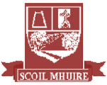

**Scoil Mhuire**

**Newsletter Spring 2018**

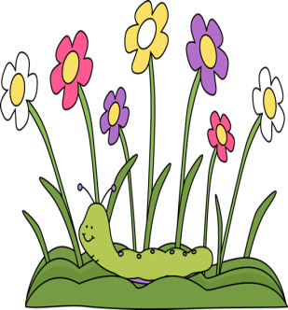



**Glenties**

Springtime is here again and it is time to dust off the old cobwebs and to do the annual spring clean!

We have a vibrant and informative Newsletter for you all to enjoy and a big thank you to all the pupils who contributed to the process of creating it! As you will read, we have had a very busy term so well done to all the children and adults for their achievements since January.

In this newsletter:

* World Book Day
* Seachtain na Gaeilge
* Arts & Crafts
* BizWorld
* Museum Visits
* Music
* Children’s Poetry
* Quiz Success
* Sports
* Competition...

and much more!

I would like to wish Mrs Rodgers all the best on her maternity leave and thank her for all the hard work she has done. I welcome back Seamus Bonner to the staff and would like to acknowledge all the help Eamon McNelis gave the school whilst Seamus was absent. Thank you to our Board of Management for all their time and effort governing the school and to the Parents’ Association for their ongoing fundraising and planning of events. We appreciate all the work you do for the children and the school.

Congratulations to 6th Class on making their Confirmation and to their teachers Ms Anne McGill and Ms Paula Bonner on having them so well prepared. Special thanks to Father Gerard for his visits to the school and the spiritual guidance he provides the children. Best wishes to the 2nd class making their First Confession and First Holy Communion this term-I just know you will be wonderful!

I hope you all had a very Happy Easter and that the Easter Bunny came!

Maria Stewart (Acting Principal)



**Confirmation**

Congratulations to all the boys and girls in 6th Class who celebrated their Confirmation in February. They have visited the Comp since then and are gearing up to attending it in September. Meanwhile, they continue to be fantastic role models for our younger boys and girls in the school. Well done, guys!

**Welcome!**

A warm welcome to Lucy Morgan (Senior Infants), TJ Byrne (2nd Class), Kelsey Boyle (1st Class) and Shane Boyle (5th Class) who have joined us since January. We hope you have a wonderful time with us in Scoil Mhuire!

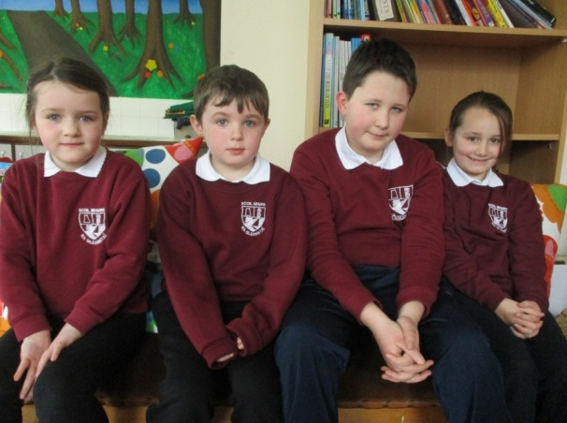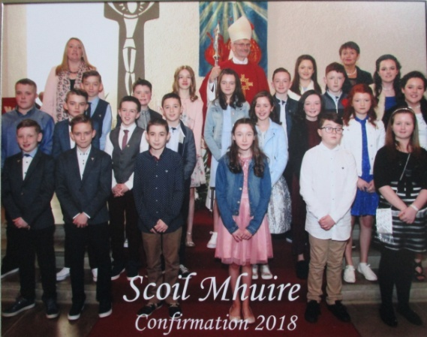

**BizWorld Visits 5th Class**

In conjunction with Bank of Ireland the 5th Class took part in an exciting, hands-on programme called ‘BizWorld’. In it, we worked as directors of a company team and learned about the world of business. By taking part, we were communicating, negotiating and developing a socially responsible business. In this programme we developed a number of products. The workshop came to life when members of the business community acted as the ‘Dragons’. The ‘Dragons’ were Kathleen Boyle from Bank of Ireland, Joe Brennan from Joe’s Tech Help and Mr. Regan. We took part in the ‘Bizfactor’, where the ‘Dragons’ were the judges and we presented our products. We outlined to the ‘Dragons’ its name, its functions, its price, how much money it took to build, which company would rival it and how it could change everyday life. It was educational and tremendous fun!

By Elijah Sangha and Phélim Boyle

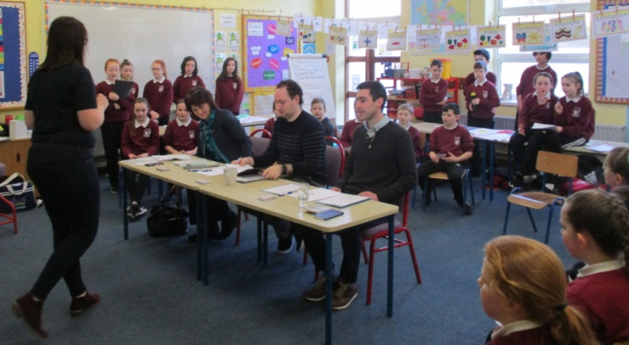

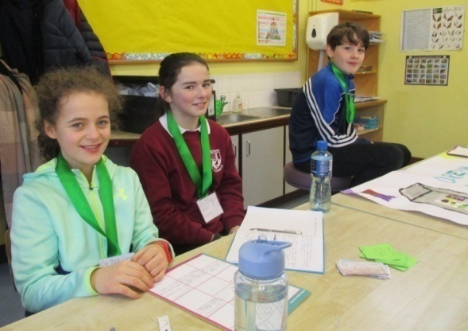

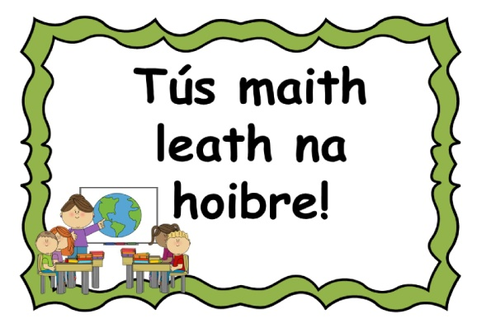

**Music, Art, Tech!**

Well done to Dervla Hegarty in 5th Class who produced a Scratch project which was an animated video for Ed Sheeran’s song ‘Galway Girl’. Her project even got a mention in the national children’s magazine *The Primary Planet*! This is the second time for Dervla to feature in this magazine as she previously had a book review published. Check out her video online!

**Gaudí Art**

The 1st and 2nd Class have been learning about the famous Spanish architect, Antoni Gaudí. They have created their own Gaudí-inspired artwork using tissue paper to give a mosaic effect. Maravilloso!

**Fire Station Visit**

Miss Kerrigan’s Junior and Senior Infant class visited the Fire Station in January and learned all about the work the fire officers do. They also learned a few important fire safety tips!

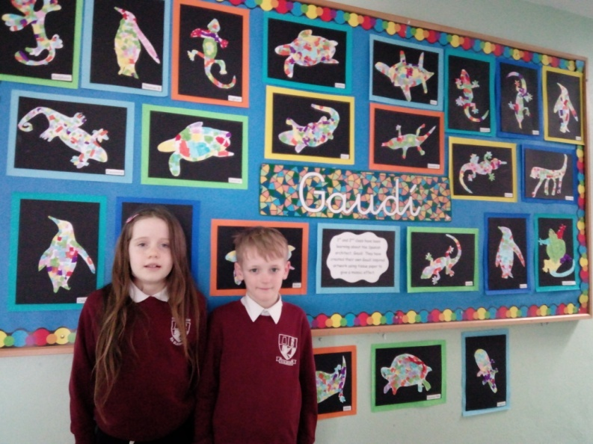

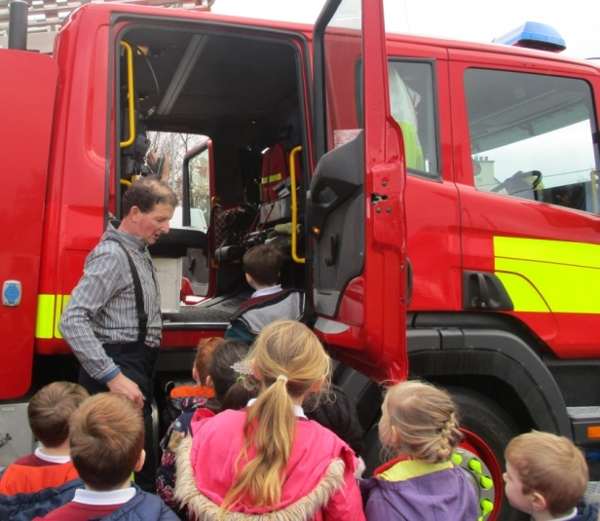

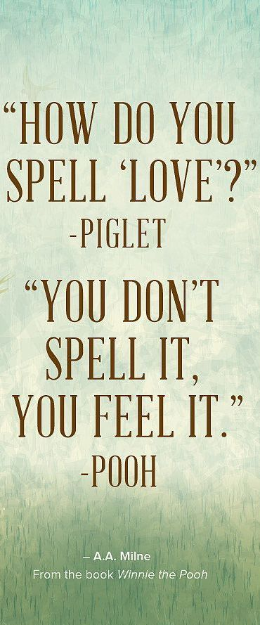

**Pancake Tuesday**

On Pancake Tuesday everyone got to enjoy yummy and nutritious pancakes! Everyone got to have a delicious homemade pancake each with a nice topping of either lemon, chocolate spread, sugar or butter.

By Cathy Browne

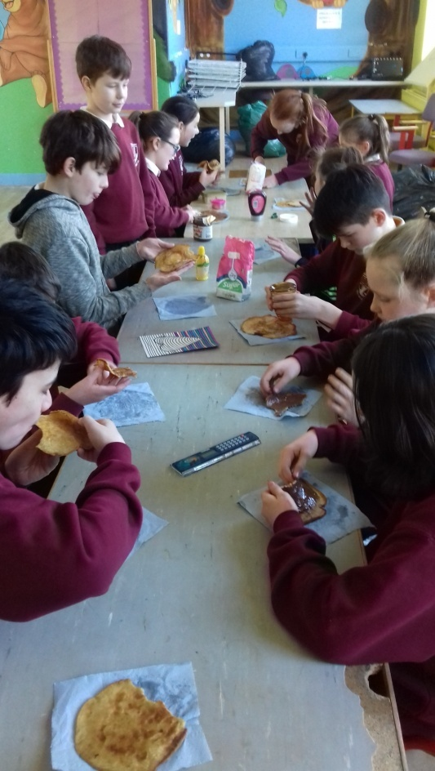

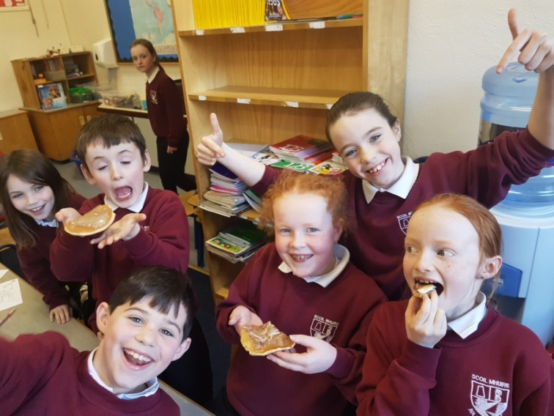

**Céilí Dancing**

Recently all the classes ranging from Junior Infants all the way up to 6th Class had to put on their dancing shoes for some Céilí dancing! We have learned numerous dances such as 'The Sweets of May', 'The Walls of Limerick', 'The Siege of Ennis' and 'The Highland'. We had a marvellous time dancing and learning along the way. We took part in dancing every Wednesday for eight weeks and all of the children had an absolutely splendid time. We thank Clement Gallagher for teaching us and for giving us those wonderful weeks!

By Tierna Brannigan

**An Grianán Theatre & Museum Visit**

On the 6th of March the 5th & 6th Classes attended An Grianán theatre in Letterkenny to see ‘Private Peaceful’ based on the novel by Michael Morpurgo. The play was about a boy named Tomas Peaceful and his brother Charlie Peaceful who both fought in the First World War and the love they had for their family. When the play was finished we walked up to the County Museum where we got a tour of the exhibition ‘Landed Gentry of Donegal’ from the curator of the museum. We found out about life in big houses such as Glenveagh which used to be a landlord’s house before it became open to the public. In the museum there was a special moustache cup, a blue silk wedding dress, old clothes and there were pictures of the houses and the people who lived in them. We even got to dress up in the fancy clothes the wealthiest people wore! It was a new experience for most people and everyone learned something new!

By Orla Molloy

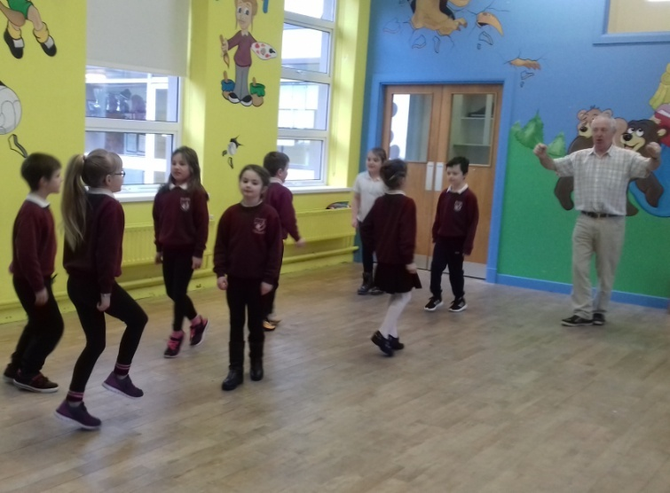

**Easter Egg Hunts!**

Miss Kerrigan’s Junior and Senior Infant Classes and Mrs. Boyle’s 1st and 2nd Classes enjoyed an Easter Egg hunt before the Easter holidays! There was huge egg-citement whenever an egg was spotted! Luckily for everyone, there were loads to be found!

**St. Connell’s Museum**

On the 22nd of February, 5th class went to the Glenties Museum and saw some very old and intriguing things such as stuffed animals, toys from decades ago, a spinning wheel, the wreck of a World-war plane, bog butter and lots more. We found out there used to be a train station in Glenties! We saw posters, tickets, timetables and the old station clock. We learned so much and it was right on our doorstep!

By Dervla Hegarty

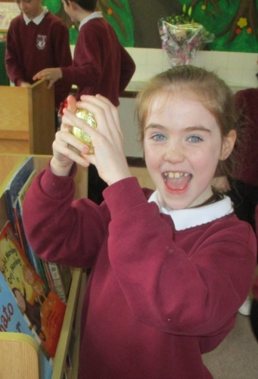

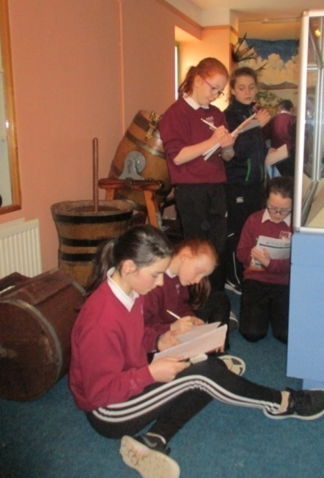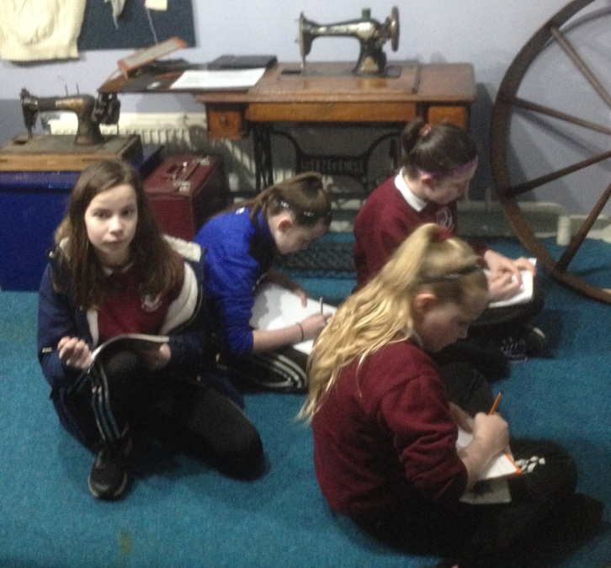

**Dreams**

When dusk is done

And the grey has gone

And the stars blow out

That once were on

Then the pale moon casts

Its frozen gleams

And the hollow of night fills up with dreams:

Rock stars dream of playing guitars

Astronomers dream of gazing at stars

Jackdaws dream of shiny things

Women dream of diamond rings

Singers dream of being famous

Teachers dream of being able to tame us

Artists dream of art exhibitions

Children dream of winning competitions

Authors dream of a best-selling book

Peter Pan dreams of Captain Hook

Which dream do you have?

Is it any of these?

I would like to know,

Would you tell me please?

By Emma Bonner, 6th Class

**Parents’ Association Fundraisers**

Thank you so much to the

Parents’ Association who

have been busy preparing

fundraising events for

our school. This year at

the Highlands Hotel on Friday 27th of April at 8:00pm the Parents’ Association are holding a ‘Say Yes to the Dress’. Any dress that won’t be worn again can be donated to the school. The money will go towards funding things such as swimming and laptops for the school. We would be delighted to see you all on the 27th for what promises to be a fun night! The Parents’ Association also organised an Easter Raffle which took place at an assembly in the school. So many people took part and everyone in the school is so grateful. There were three hampers raffled which consisted of Easter eggs, chocolate eggs, Easter decorations, a chick teddy, chocolate bars and a chocolate chick. The winners were Claire McElwee, Eamon Boyle and CJ Laverty Thanks to everyone for your continued support!

By Rachel Boyce, Charlie Quigley & Áine Brannigan.



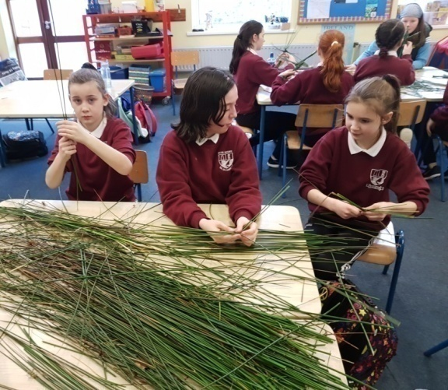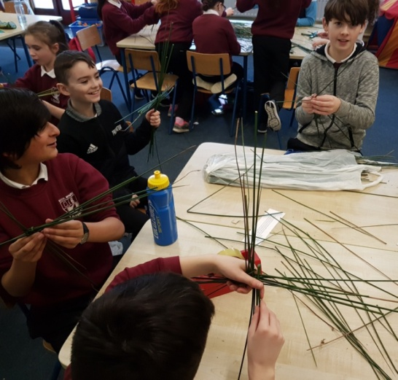

**St. Brigid’s Crosses**

We celebrated the feast day

of St. Brigid on February 1st

by making crosses. It was a

fun way to learn about our

second patron Saint and the

afternoon of activities and

chat flew by!

**Aistear**

The children in Junior and Senior Infants have been continuing to reap the benefits from the Aistear curriculum framework which they have been engaging with this year. They have been learning to communicate, explore and think and have gained a greater sense of identity and belonging through the Aistear programme.

**Owenea FM**

Charlene Campbell and Rebecca Quigley did an amazing performance reciting a poem on Owena FM during the Christmas holidays. The poem was made with the help of Maria Mc Loone and Ailbhe Doherty. The poem was called ‘Spread the Joy’ and sure enough it was Christmas themed! Other pupils from other schools also took part in this and they were all brilliant as well. Well done Girls! ☺

By Charlie Quigley & Áine Brannigan

**Spread The Joy**

Spread the joy this Christmas Day

And don’t forget to sing and pray

For this is the day when Jesus was born

And everyone danced upon the morn.

Spread the joy this Christmas Eve

When everybody was relieved

Of their sorrow, strife and sadness

And it was replaced by joy and gladness

Spread the joy around the world

When happiness was unfurled

Everybody yelled ‘hooray!’

So spread the joy this Christmas Day.

By Maria McLoone, Charlene Campbell & Ailbhe Doherty.

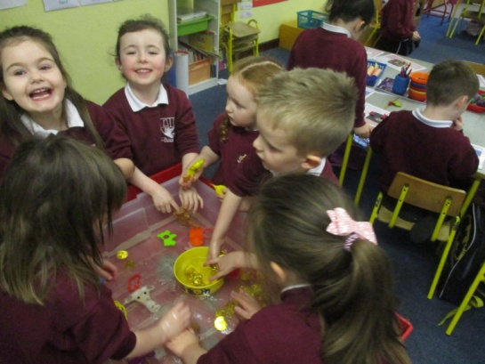

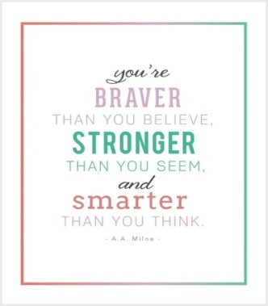

**Bricks4Kids**

As part of Engineering Week which took place in February all classes enjoyed a stimulating visit from Bricks4Kids. Children had the opportunity to build a lego, motorized bulldozer by following instructions. The workshops developed our teamwork and problem-solving skills. We also now have a greater appreciation for how things work!

By Kian Kennedy

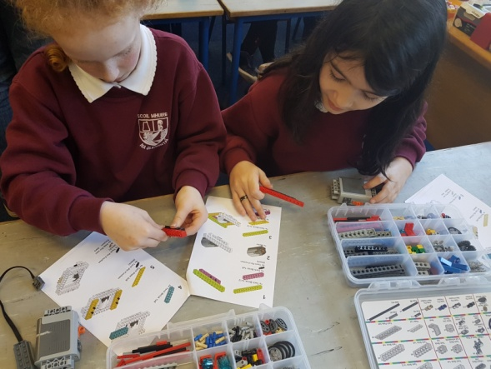

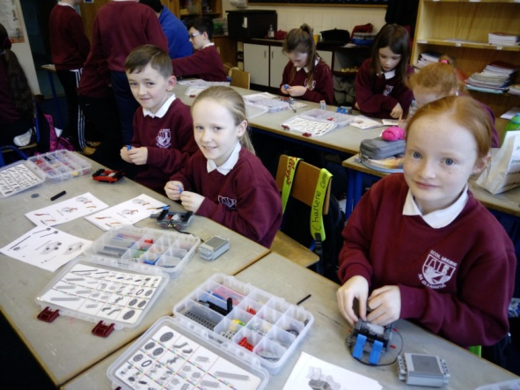

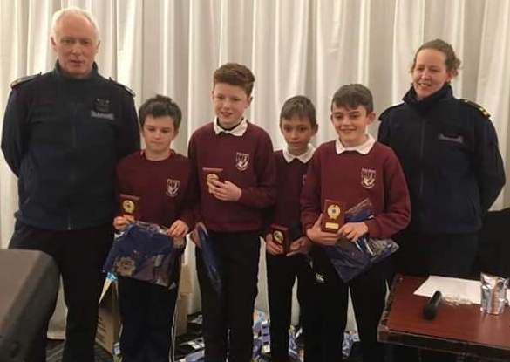

**Quiz Success**

Do you know what kind of an animal a mallard is? This was one of the tricky questions on one of the recent quizzes which our school participated in. The school had huge success at the Garda Divisional quiz which took place in Donegal Town in February. The team, consisting of Adam Hanlon, Conor Gildea, Tiarnán Ward and Daniel Quigley, finished top out of 32 teams to claim winners’ shields, medals and Garda t-shirts. They even finished fourth in the county final a couple of weeks later with a terrific score! What an achievement! Meanwhile, the junior and senior teams performed very well in the Credit Union Quiz which took place in Inver finishing in second and fourth position! On the junior team were Maria McLoone, Áine Brannigan, Cian Gildea and Lara Lynch while Dylan Campbell, Marc Gavigan, Conor Gildea and Kian Kennedy represented the senior team. Keep up the great work, guys!

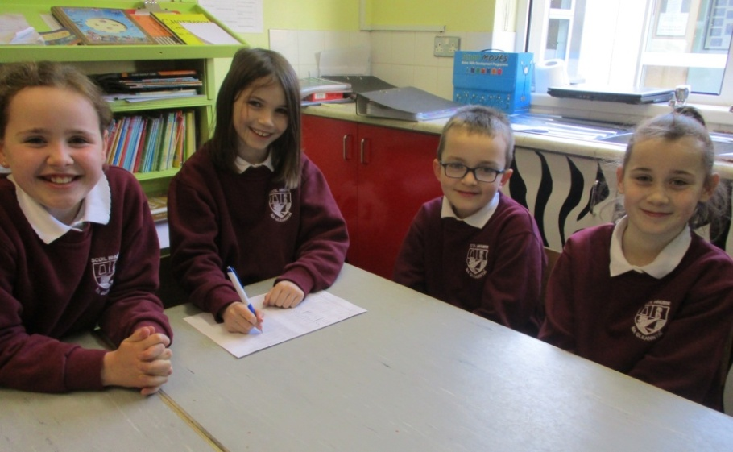

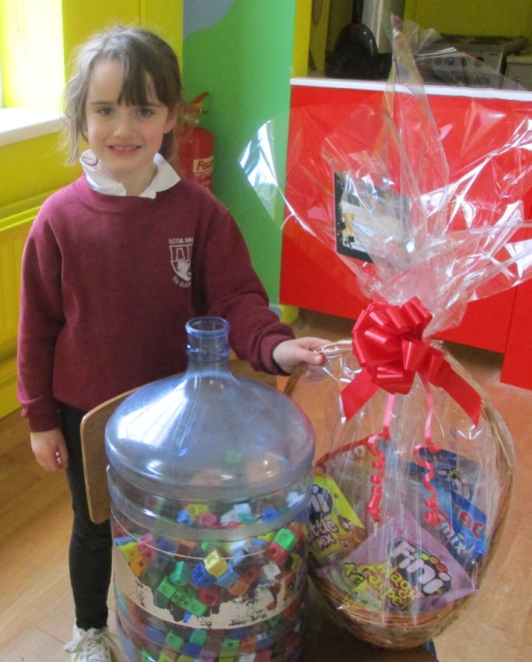

**I Have a Dream...**

That people will stop judging by the colour of their skin and start judging by their heart ~ Conor Farrell, 3rd Class

That the homeless will be off the streets & live in a nice, cosy home ~ Tiarnán Campbell, 3rd Class

That all animals would be safe and protected... that dogs be kept in warm, cosy homes, be given attention and be appreciated ~ Orin Brannigan, 4th Class

That this nation would be fitter once again... that there would be more sports, cycling, running and walking – Daniel Breslin, 4th Class

That people will bring peace to the world ~ Noah Bonner, 4th Class

That we should talk about our problems instead of fighting ~ Rachel Boyce, 4th Class

**Maths Winner**

The boys and girls used their estimating skills in February to guess how many cubes were in the entire school when they were all placed into a water drum. There were a total of 872 cubes in the drum and Niamh Heekin Sweeney was the winner with a closest guess of 900. Congratulations also to Kori Browne, Jay Hegarty, Annie McGlynn and Sophia McGettigan who all came third with the guess of 1000. Charlene Campbell came second with a guess of 955. Well done to everyone!

By Conor Farrell, Cian Gildea and Ciaran Boyle

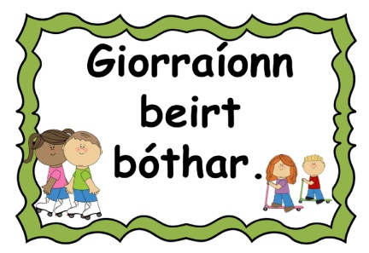

**Coming up!**

* **Swimming** for the 5th & 6th Classes in the Finn Valley Centre for the first eight Wednesdays of the last term.
* Aengus Kennedy from Heritage Ireland will be taking each class for a **Habitat Study Day** in April and May.
* **Book Fair** takes place this month.
* **Active Schools Week** takes place 23rd – 27th April.
* We are holding a **Cash for Clobber**. Any unwanted clothes can be left in to the school.
* **‘Say Yes to the Dress’** takes place in the Highlands Hotel on Friday 27th April at 8pm.
* On Friday 4th May the school will be closed for a staff in-service day and will reopen on Wednesday 9th May.
* **Holy Communions** are Saturday 12th May.
* Finn Harps Fran Fields **soccer competition** takes place Thursday 17th May.
* **Sports Day** takes place in June. Preparations have begun already!
* The school will close for summer holidays on Friday 22nd June at 12.30pm.
* If your child is absent from school for any reason, please send in an explanatory note to school.
* There have been some slight changes to the food options on the lunch menu. Make sure to log on and check that your order is correct!

**Eason Spelling Bee**

The boys and girls from 5th and

6th Classes are busy preparing for

the annual Scoil Mhuire Spelling

Bee which takes place very soon.

A spelling competition will be

held to see who will represent

the school at the County Final

stage which takes place in

Letterkenny on the 10th May.

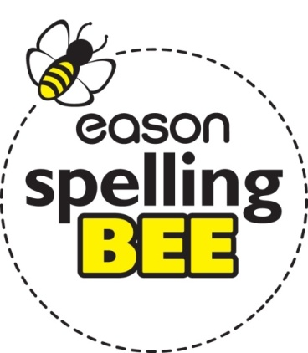

**Spring Clean!**

On Wednesday 21st of March Scoil Mhuire went litter-picking. The Junior and Senior Infants went around the school grounds and park while The 1st and 2nd Classes tidied up around the Chapel, the park and a bit of Stone Park. The 3rd & 4th Classes did a huge clean-up around The Rock, Altar and back down the town. The 5th Class went around Tullyard and the 6th Class went around Meenahalla. Altogether the total amount of bags collected was approximately 30 – 40 bags of rubbish. What a day’s work!

By Erin Bonner and Shauna Molloy (4th Class)

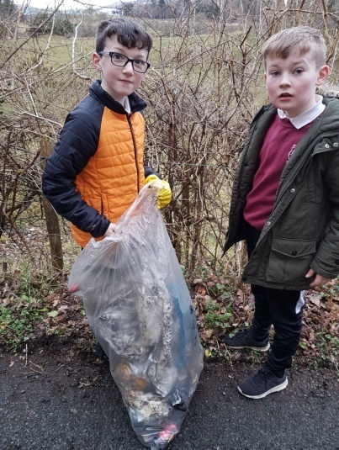

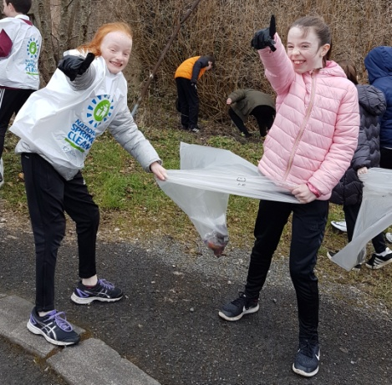

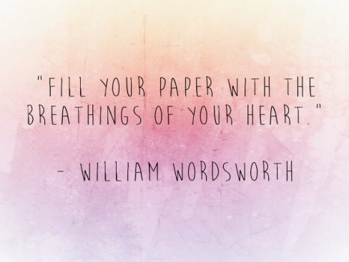

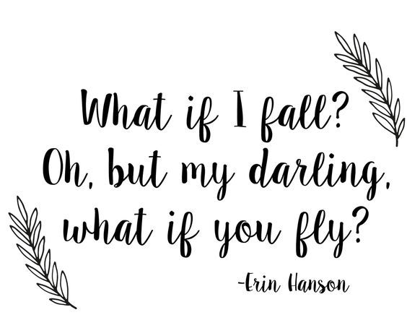

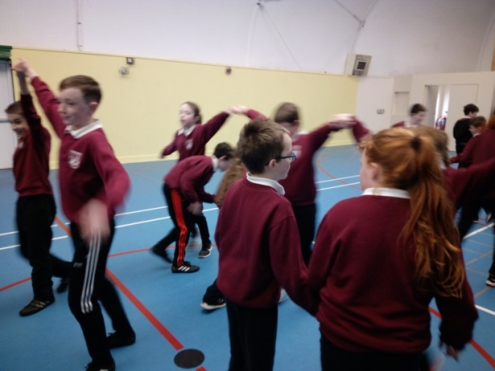

**Seachtain na Gaeilge**

Tá súil againn gur bhain sibh uilig taitneamh as Seachtain na Gaeilge. Rinne muidinne Seachtain na Gaeilge a cheiliúradh i Scoil Mhuire. Bhí a lán gníomhaíochtaí againn mar shampla Tráth na gCeist as Gaeilge, Céilí, ceolchoirm Gaelach agus bhí duaiseanna do na daltaí a rinne an iarracht is fearr Gaeilge a labhairt i ngach rang.

Le Danielle Kennedy, Maria Mcloone agus Rebecca Quigley (Rang a Trí)

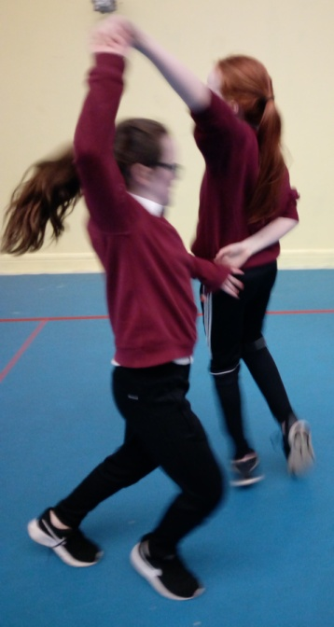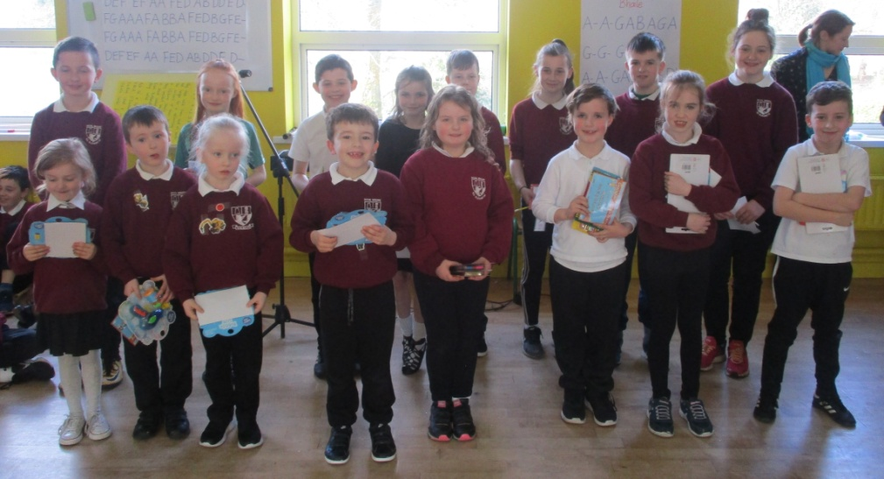

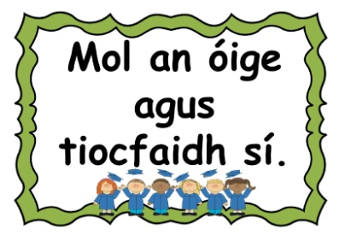

**Tin Whistle & Recorder**

The boys and girls in the school have been very fortunate to have Miss Kerrigan and Ms. Connole teach them the recorder and tin whistle. They have been practising earnestly over the past few weeks and performed some of the songs they learned at a school assembly before Easter. It sounded beautiful!

By Karolina Byrne & Jay Lynch

**Easter Art**

The 1st and 2nd Classes were busy doing artwork before the Easter holidays. The budding artists produced beautiful Easter pictures of bunnies and eggs and ‘card on crayon’ art pieces depicting the holy crosses on the Hill of Golgotha which they were learning all about in the lead up to Easter Week.

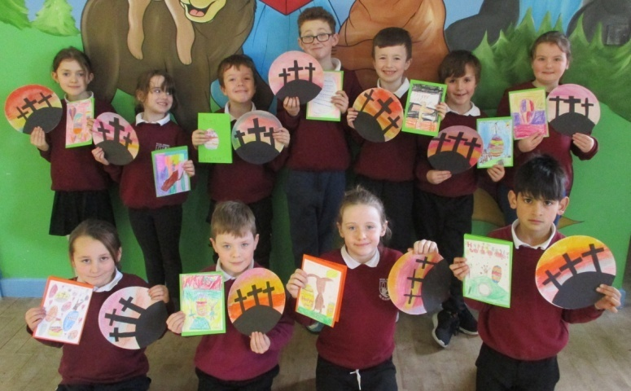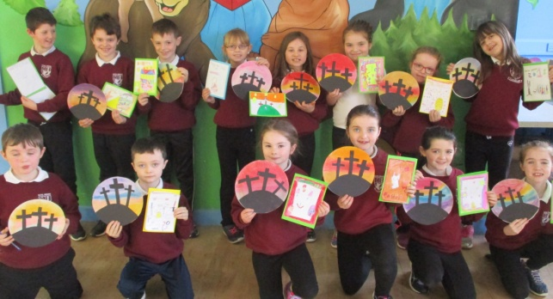

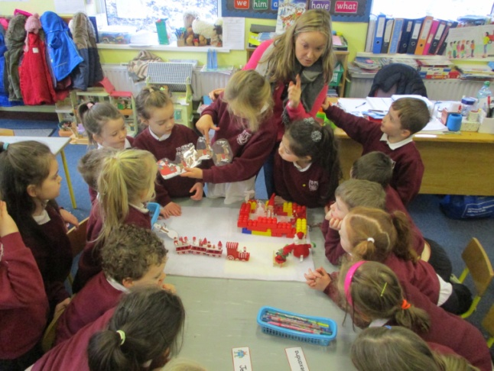

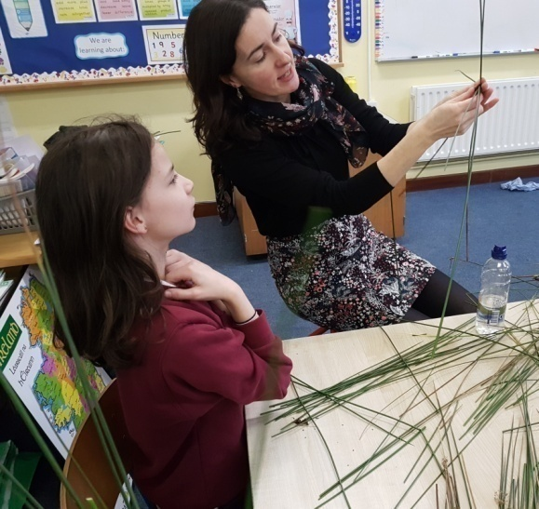

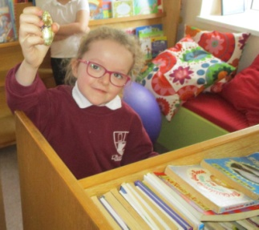

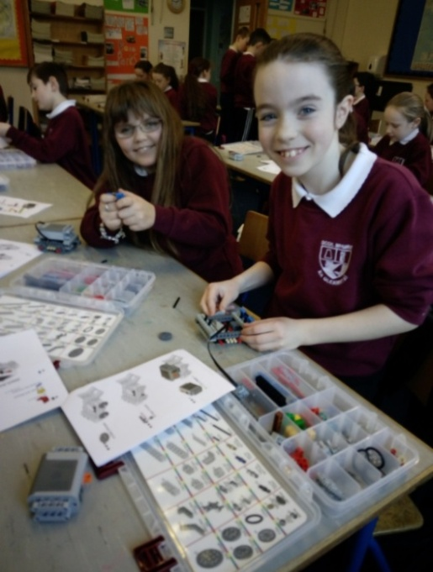

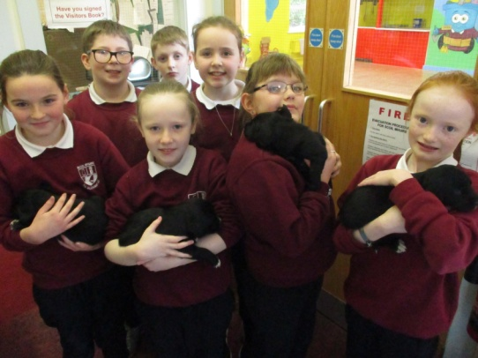

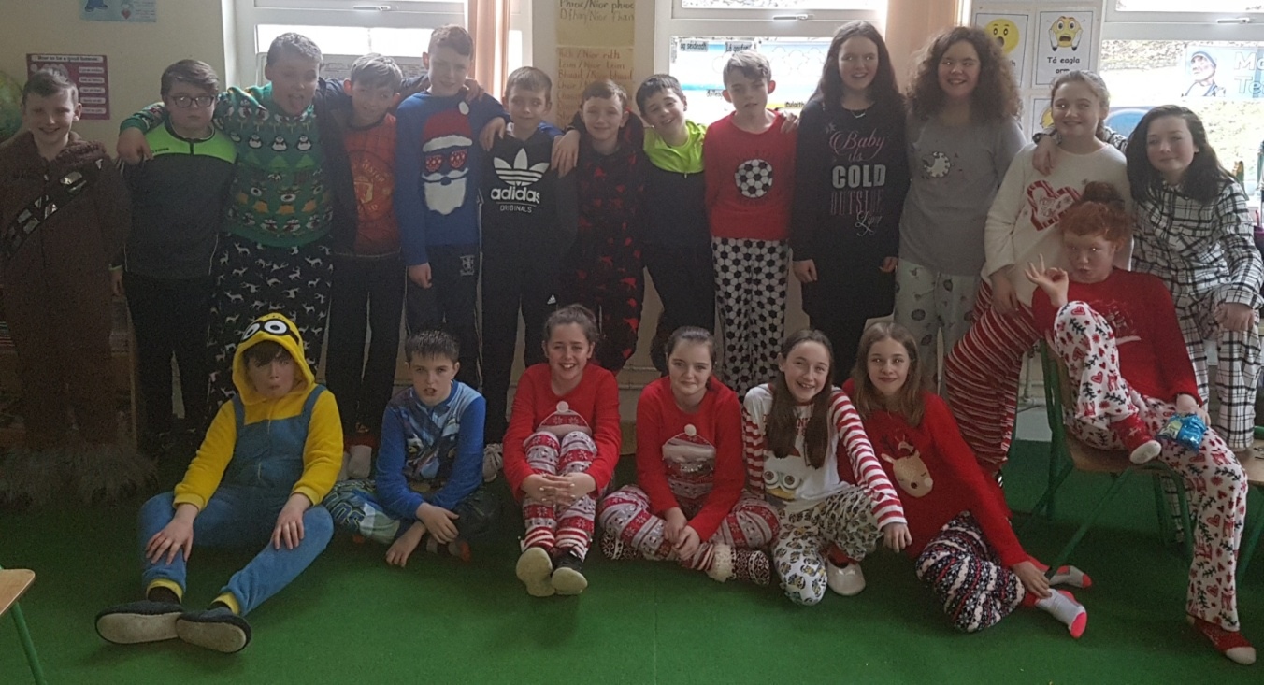

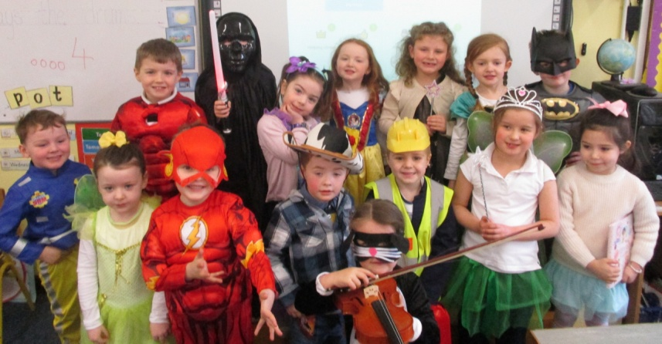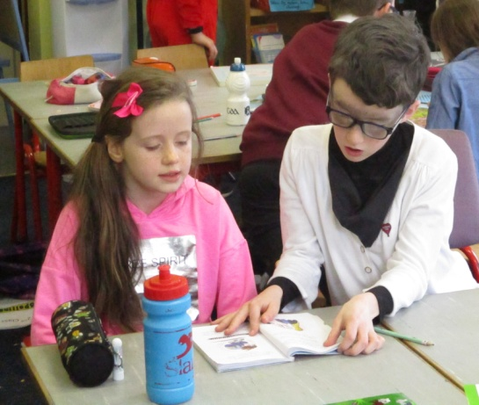

**World Book Day 2018**

**We celebrated World Book Day on Wednesday 15th March. A lot of pupils and staff dressed up as their favourite story character. We had Mary Poppins, Matilda, Harry Potter, Sophie from *The BFG*, Cat in the Hat and many, many more! Children also wrote about their favourite story character, did reading buddies and made bookmarks! Here’s a further flavour of the fun we had!**

**By Eva Breslin Ward, Bethany Gilroy and Emily Browne**

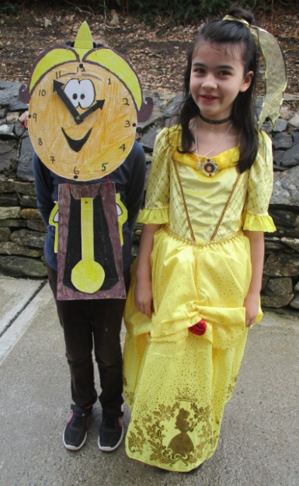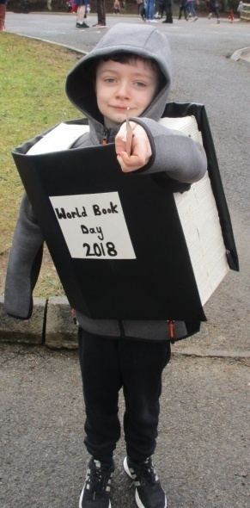

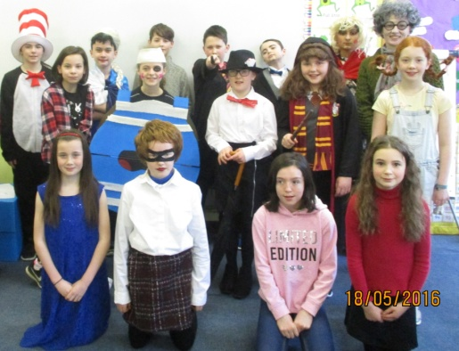

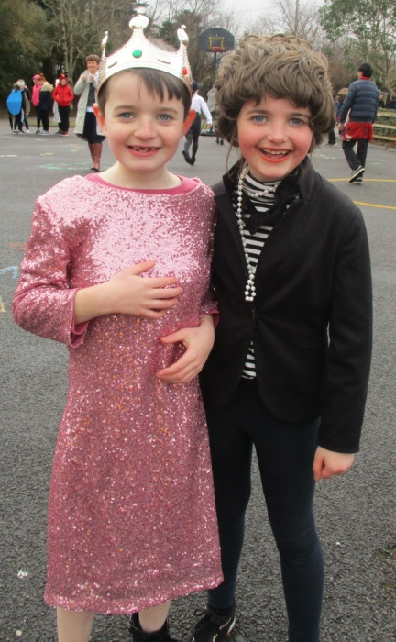

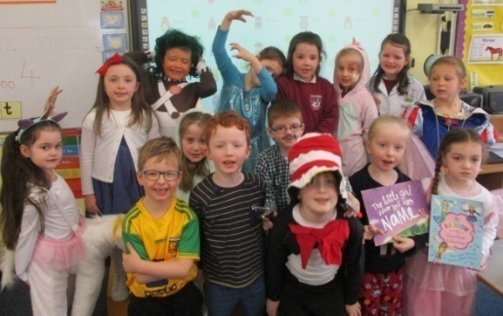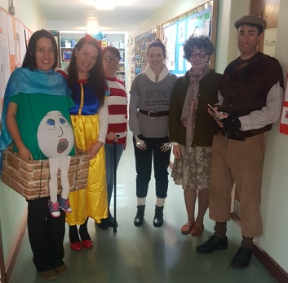

**Gaelic Football**

Both our boys’ and girls’ teams progressed to the second round of the Allianz Cumann na mBunscol Gaelic football competition after a first round win before Easter. Our girls’ team defeated St. Connell’s from Portnoo over two legs in a very close tussle. The girls played some fantastic football and now play St. Nauls in the next round. The boys were well beaten in the first leg but made an astonishing comeback in the second leg in the Comp pitch to force a play-off. Again, our lads showed their grit to come from five points down to win by a single point after extra-time. The boys are due to play Crannóg Buí/Gortnacart in the next round. Good luck to both teams!

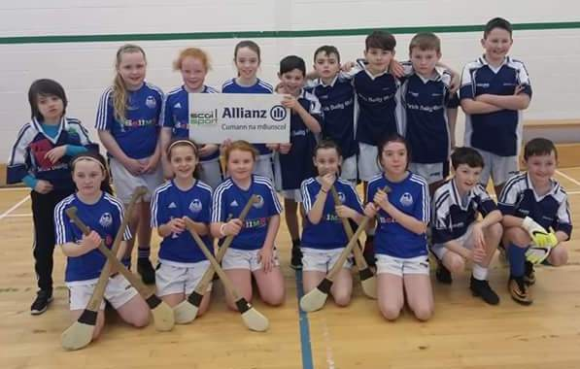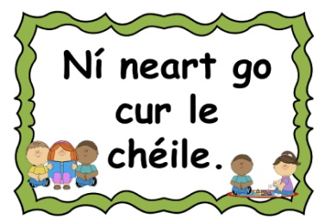

**Hurling & Camogie**

On February 23rd Scoil Mhuire took part in a hurling and camogie blitz in Gweedore. They played a number of teams including Kilmacrenan, Scoil Roisín, Scoil Chróine and Derrybeg. The girls drew three of their games and lost one of them. The boys won one, drew one and lost two. They all did fantastic!

By Charlene Campbell, Ailbhe Doherty and Aoife Mc Dermott

**— ✂ ——————————————————————————————————————**

**Competition Time!**

We have a mystery prizes up for grabs!

For your chance to win it, read the newsletter carefully and

answer these three questions. Fill in your name and class. Entries

can be dropped into the entry box at the front of the school.

Good luck!

1. What nationality was the architect Antoni Gaudí?.................................................................

2. Who is the author of ‘Private Peaceful’?.................................................................................

3. What date do we celebrate St. Brigid’s Day?.........................................................................

Pupil’s name and class:...........................................................................