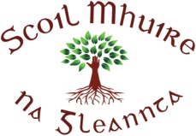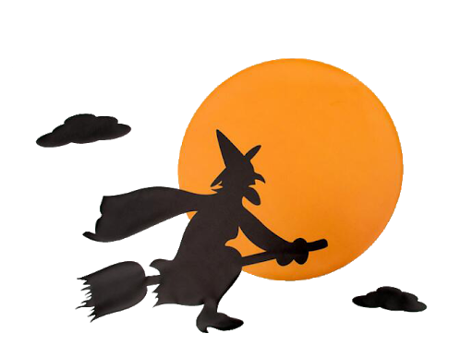

**Scoil Mhuire**

**Newsletter Hallowe’en 2020**



Dear all,

Thanks for all of your help and support with opening the school successfully during this time. I hope that everyone is as delighted as I am to be back at school.

I would like to take this opportunity to properly introduce myself. I am Miss Tracey Whyte and come from Clones, Co. Monaghan. I have worked in Dublin for over ten years after spending many years teaching in Liverpool. I will be Acting Principal while Ms. Rodgers is on maternity leave.

Glenties is such a beautiful place and I feel so welcomed in to the community. I am so happy to be part of such a wonderful school and community. The pupils have exceptional kindness and manners and they are working so hard in all classes. I would also like to mention that I am grateful to work alongside all the amazing teachers who are working so hard in the school and show so much care and kindness every day.

As you can imagine the running of the school can be busy with myself and the teachers in the classroom all day but do not hesitate to contact the school and we will get back to you at the end of the day. Once again thank you so much for following all the safety guidelines to keep the school open. Please continue to adhere to the entrance and exit points of the school and children are not to be on school grounds before 9.20 when the bell rings.

Thank you so much,

Tracey

Tracey Whyte (Acting Principal)

**Glenties**

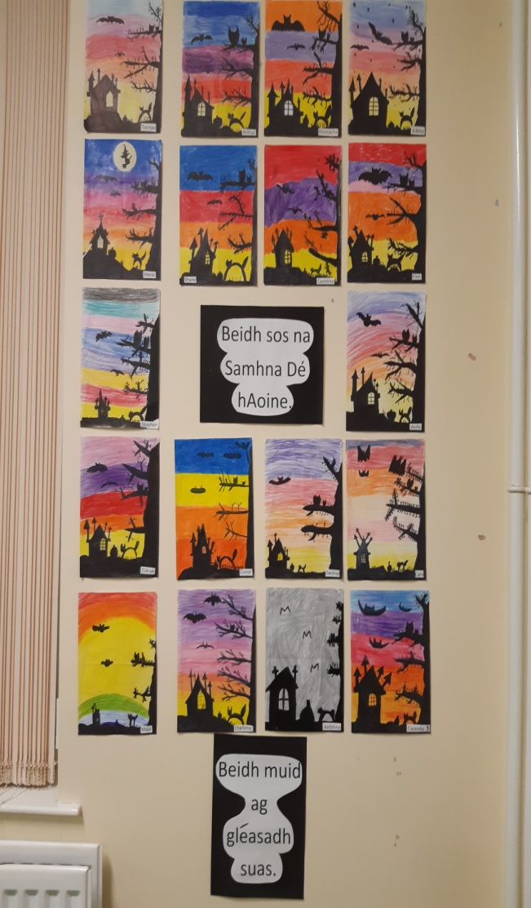

**Playground Revamp**

The children received a big surprise when they returned to school in September! Our playground was resurfaced and painted. We now have lined football and basketball areas as well as games such as Snakes and Ladders and Duck Duck Goose marked out! We received funding for this job as part of the Summer Works project. Many thanks to Brannigan Associates who oversaw the works.

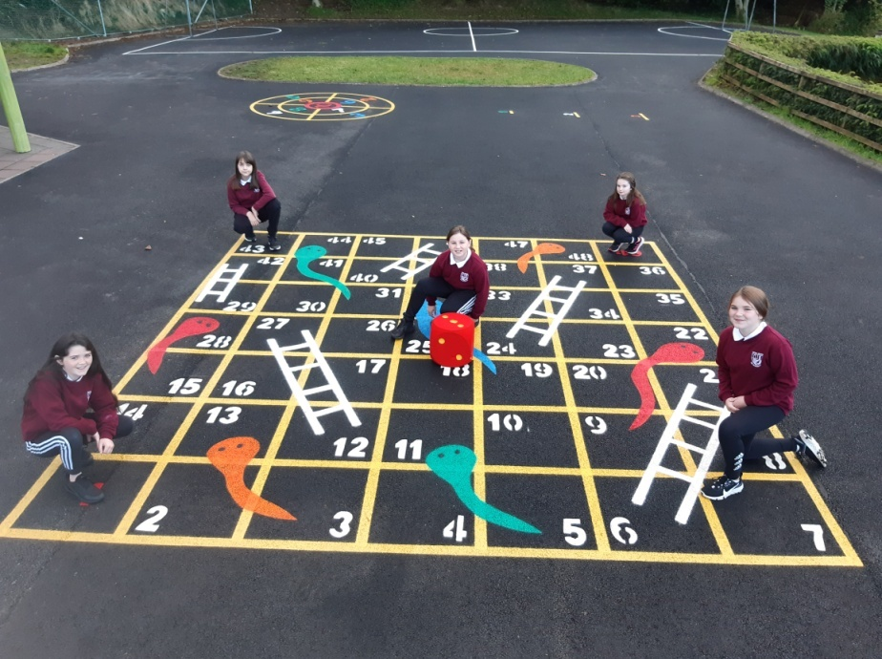

**Staying Safe!**

A huge thank you to Margaret Byrne Drimnacrosh who made wonderful masks during lockdown for all the pupils in our school. This was truly a labour of love and generosity. Go raibh céad míle maith agat Margaret.

**Welcome!**

We extend a warm welcome to the new Junior Infants who have joined us this year! We hope you make many happy memories in Scoil Mhuire! Missing from the photographs here is Sadbh Flaherty. Also, we extend a warm welcome to Caoimhe Murray who joins us in 6th Class. We’re sure everyone will help you settle in to your new school and that you have a wonderful year with us!

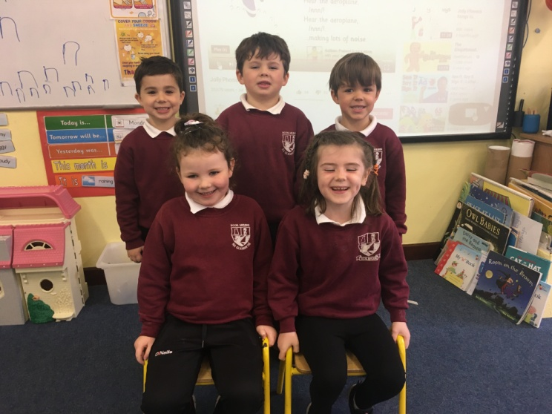

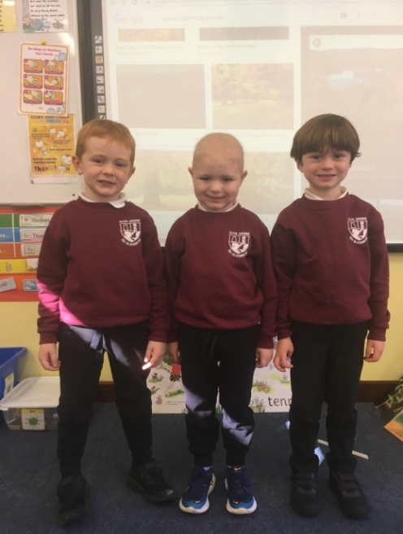

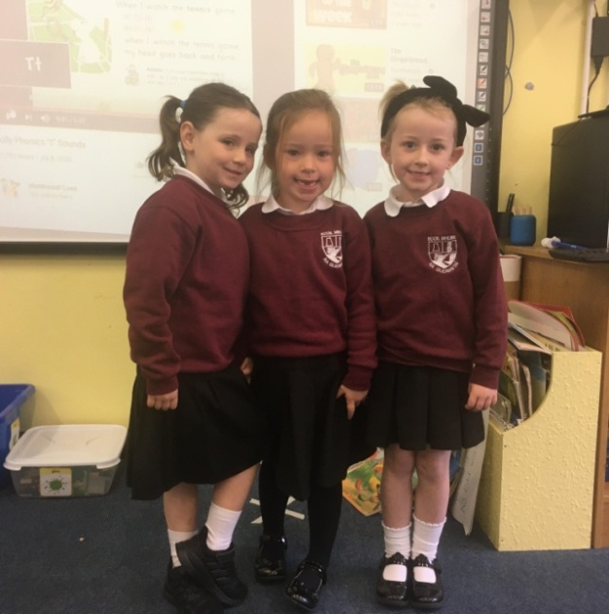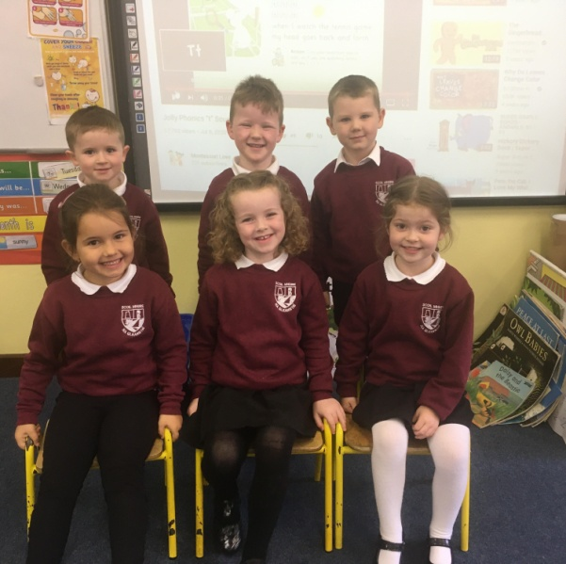

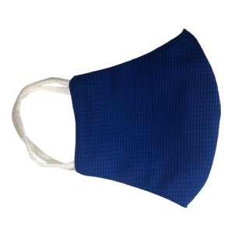

**Scavenger Hunt**

The weather was so pleasant in early October the 3rd and 4th Classes went on a scavenger hunt around the school grounds! They searched for everything from bugs to plants. They even spotted a bird’s nest and a few snails!

**First Holy Communion**

Congratulations to all the girls and boys who celebrated their First Holy Communion in August. It was a very special day for all those who could attend. We thank Fr. Gerard for celebrating this special day with the children and for facilitating them during a tricky time!

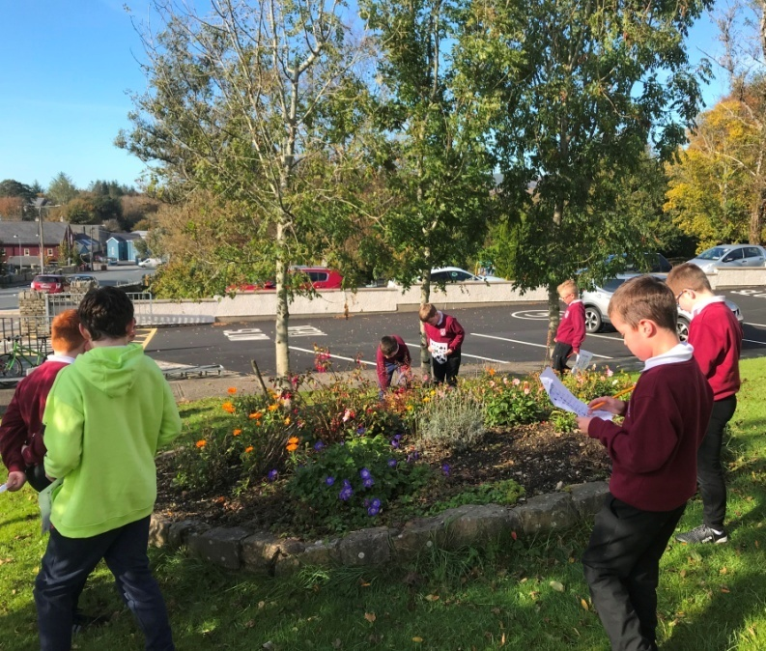

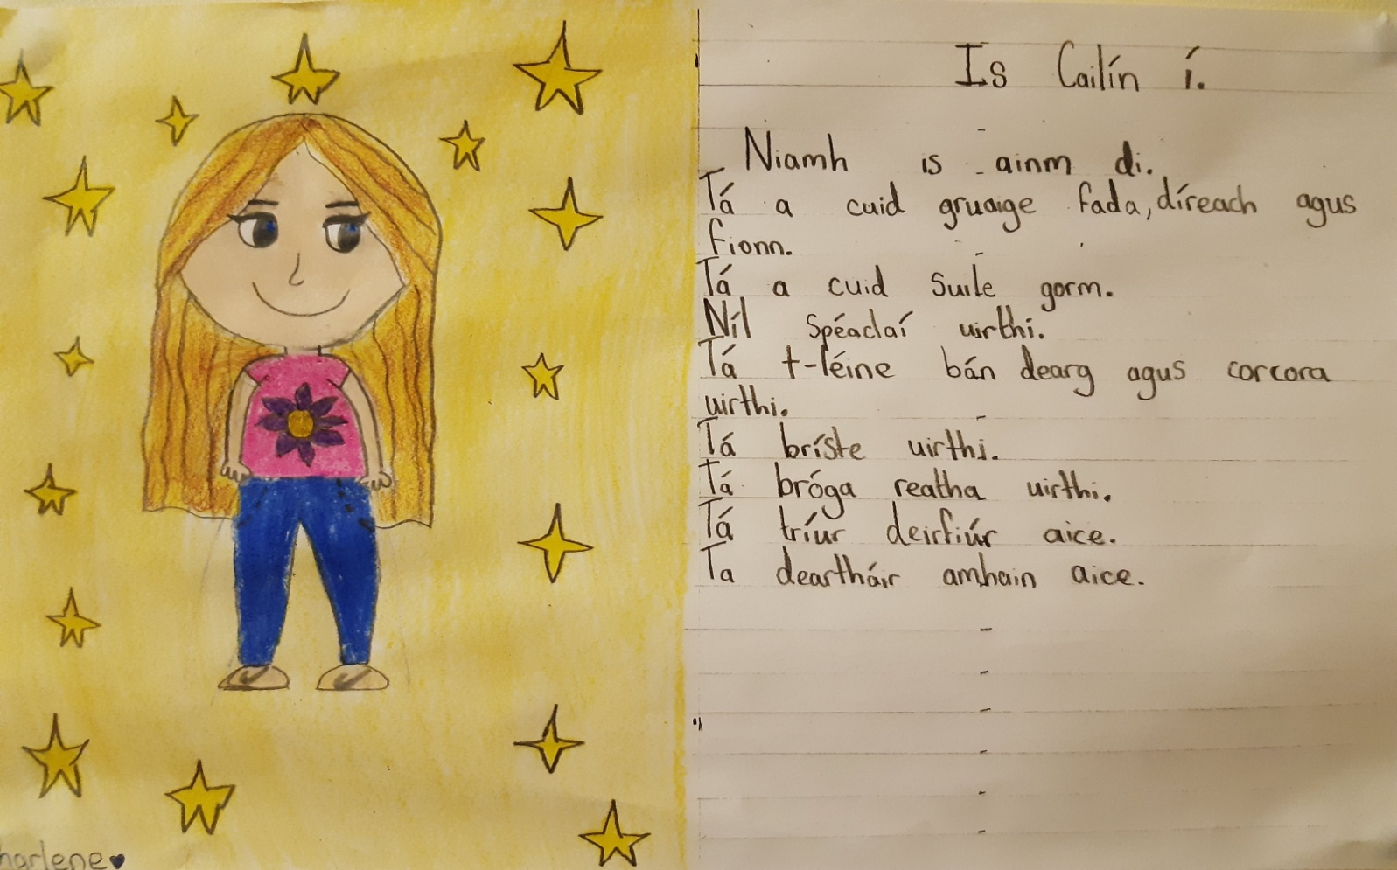

Charlene Campbell (Rang 6)

**Autumn Senses Poem**

*I see* the young children dressing up as scary witches and zombies.

*I hear* the spiky hedgehog rustling in the leaves in the dark, haunted woods of an abandoned property.  
  
*I taste* the freshly-picked blackberries in the basket in my Nana’s kitchen.  
  
*I feel* the bumpy bark of the large tree in the wet, spooky forest.  
  
*I smell* the warm pumpkin pie baked by my kind and caring Nana.

By Áine Bonner (4th Class)

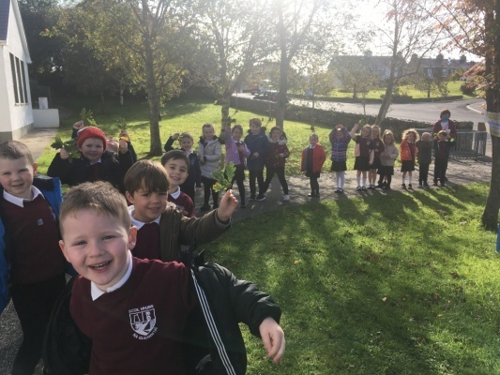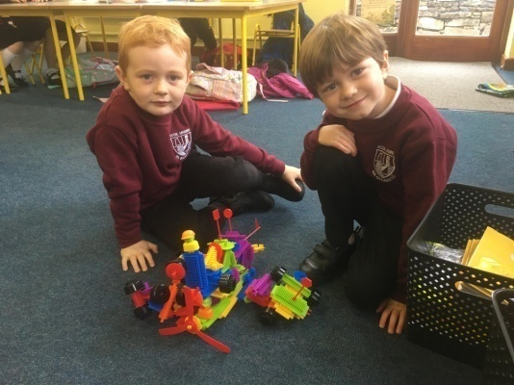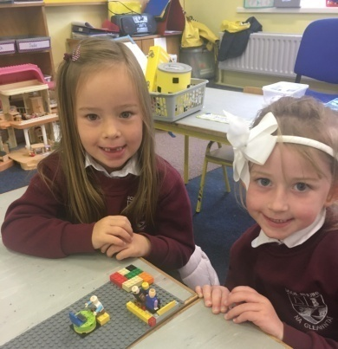

**Creative Craftwork**

Have a look on this page at some of the beautiful art and craft work the Senior Infants and 1st Classes produced this term. They did self-portraits and leaf prints from items they gathered on a nature trail. They also made spooky bats for Hallowe’en and moulded fantastic hedgehogs from clay!

**White**

Fluffy clouds in the winter sky

Freezing snow on the cold ground

Melting snowman built by happy children

Mouthwatering marshmallows in my hot chocolate

Cute, cold, polar bear on the TV show

Soft, fluffy wool on the sheep outside

Cosy, warm blanket wrapped around me

Warm tasty milk ready to drink

My mind blank when I cannot think!

By Sophie Brennan

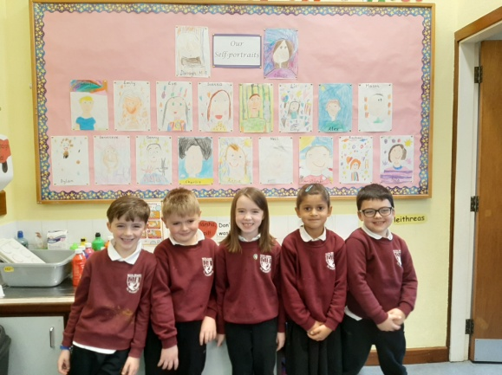

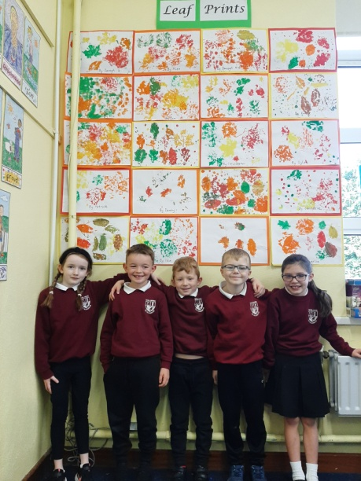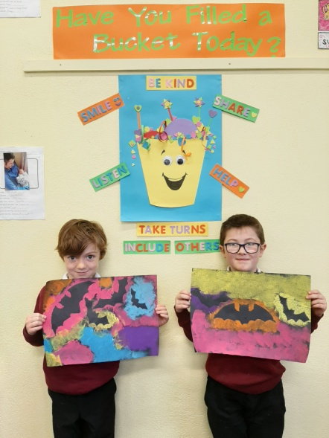

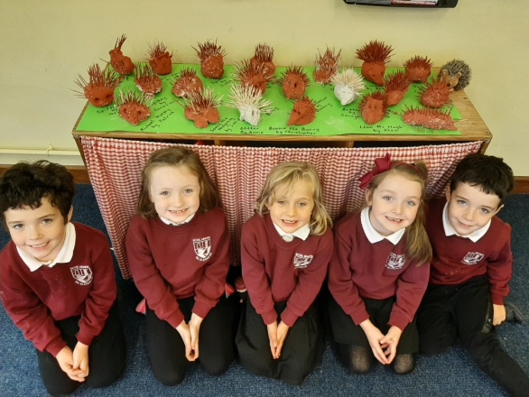

**Scavenger Hunt**

Miss Gallagher's Senior Infants and 1st Class had great fun on their Autumn Scavenger Hunt. They found everything on their list except acorns and apples which Maya kindly brought in the following day. Well done boys and girls!

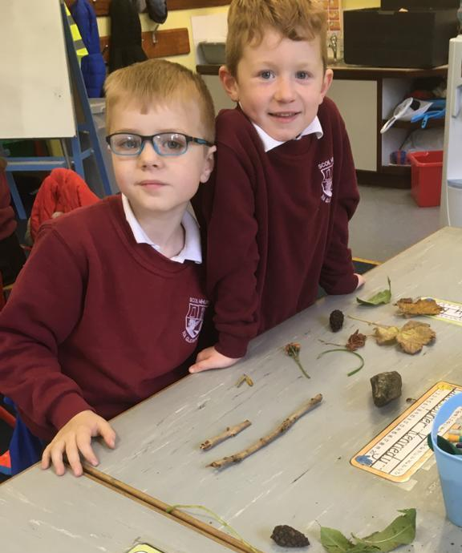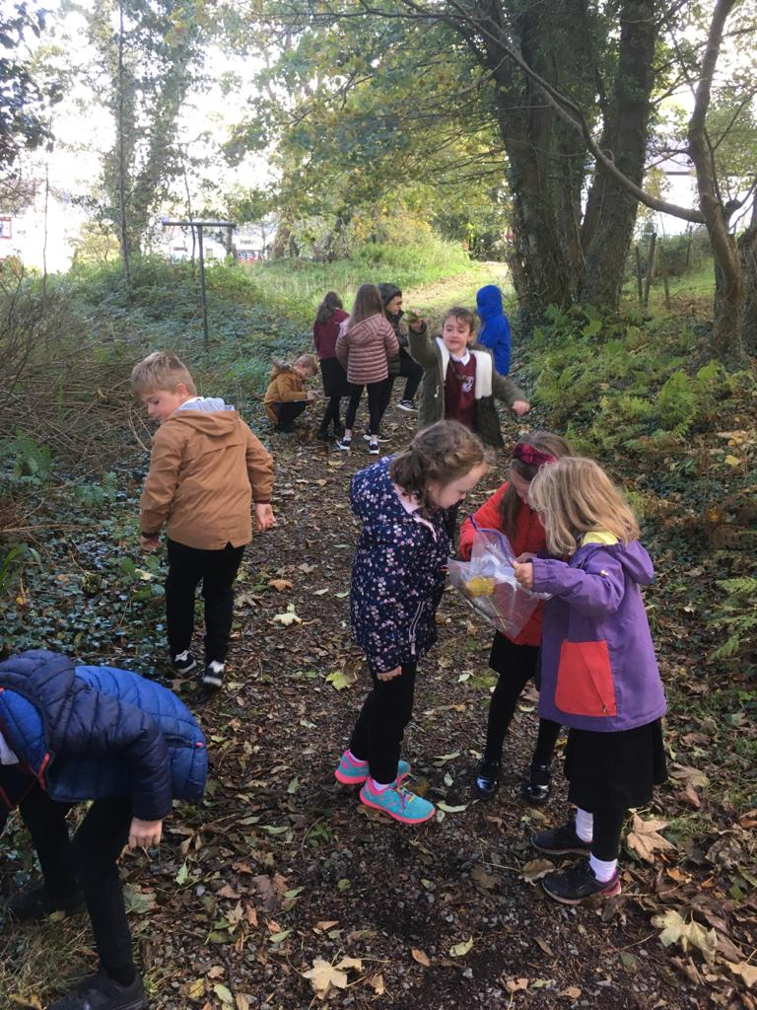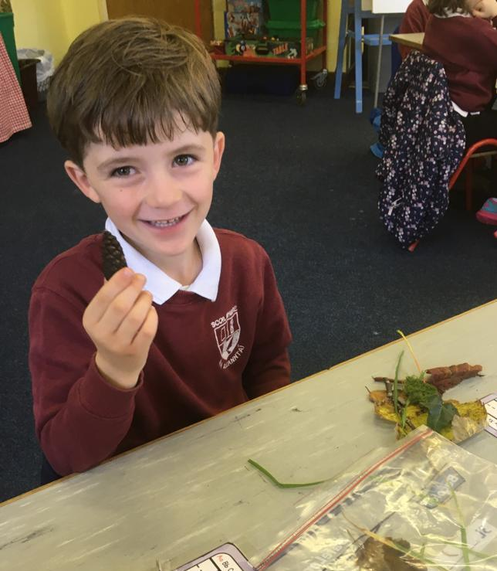

**Starbursts**

The 5th and 6th Classes got creative with the initials of their names, creating a mesmerising display of starburst letters. They also wrote a short description of themselves in September outlining all that is unique and brilliant about each and every one of them!

**Maths Trail**

The school celebrated Maths week from the 11th – 16th October. The 3rd & 4th Classes enjoyed a maths trail in the school yard. They enjoyed the fun side of maths and helped the classes plan their yard time games by measuring the area of the playing fields!

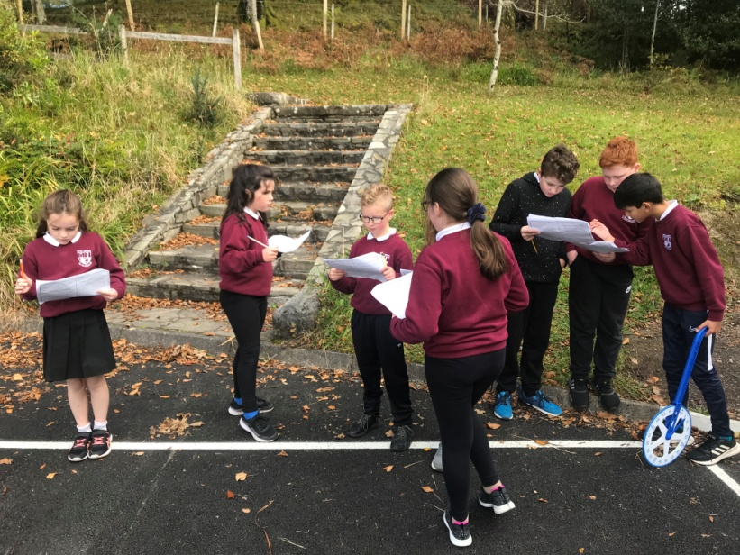

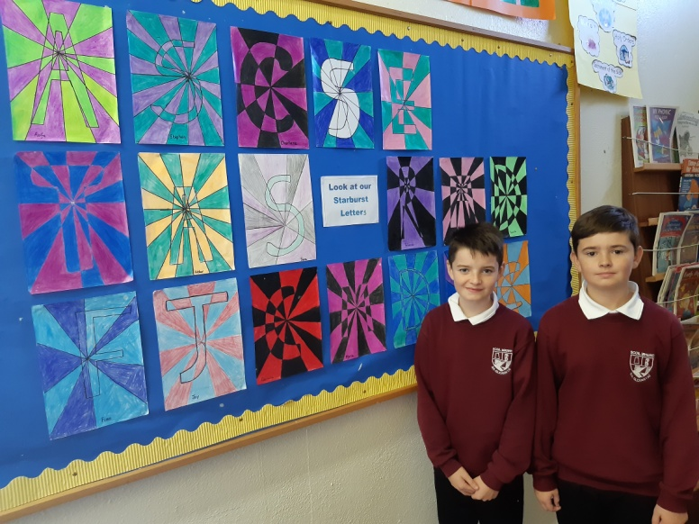

**GAA Coaching**

Thanks to Declan Bushell who has been visiting the school since September taking all the classes for GAA lessons. Declan is the new Coaching Officer in Donegal GAA. All Cumann na mBunscol activities have been suspended until January 8th but we can still practise so that we will be ready when they resume!

**Special Awards**

There have been some very special awards presented to the boys and girls since September! They were presented for kindness, Gaeilgeoir na Seachtaine and for trying really hard at school! Ms Whyte also presented awards to children who displayed great manners and excellent behaviour!

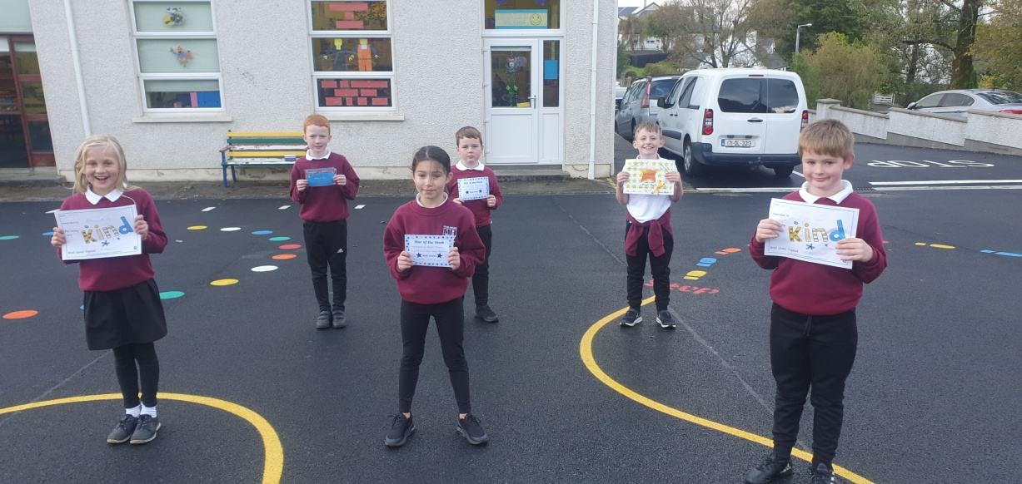

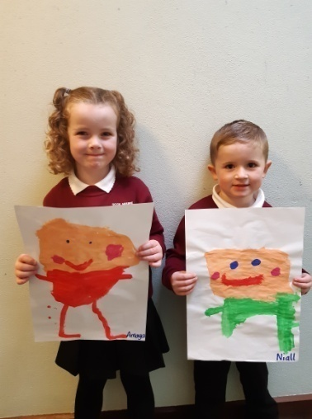

**Humpty Dumpty**

Humpty Dumpty sat on a wall... The children in Ms Kerrigan’s class were learning about what happened to poor Humpty Dumpty. After hearing the story, they painted pictures of Humpty Dumpty sitting on the wall. They also drew pictures of Jack and Jill climbing the hill to fetch a pail of water! The boys and girls had loads of fun doing the paintings and hearing the nursery rhymes!



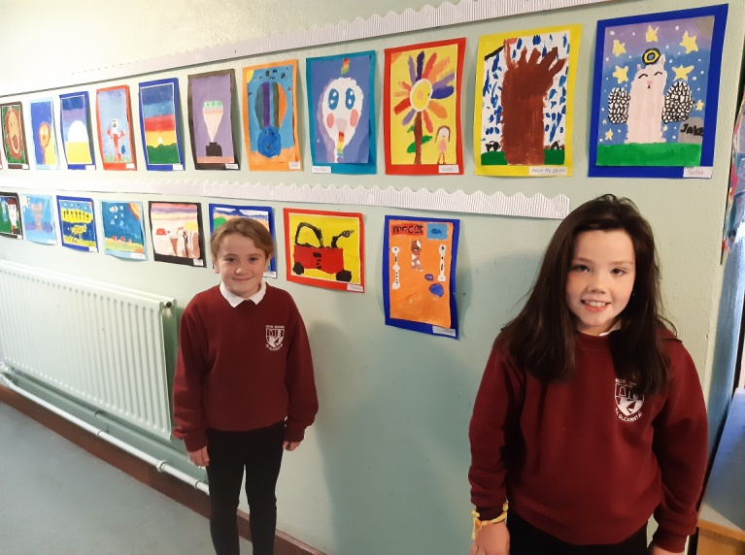

**Mixing Paints**

Ms Eleanor’s Class have been learning to mix primary colours together to make secondary colours. They learned that blue mixed with yellow will make green, yellow mixed with red will make orange and blue mixed with red will create purple. They created beautiful paintings based on their experimentation with paints!

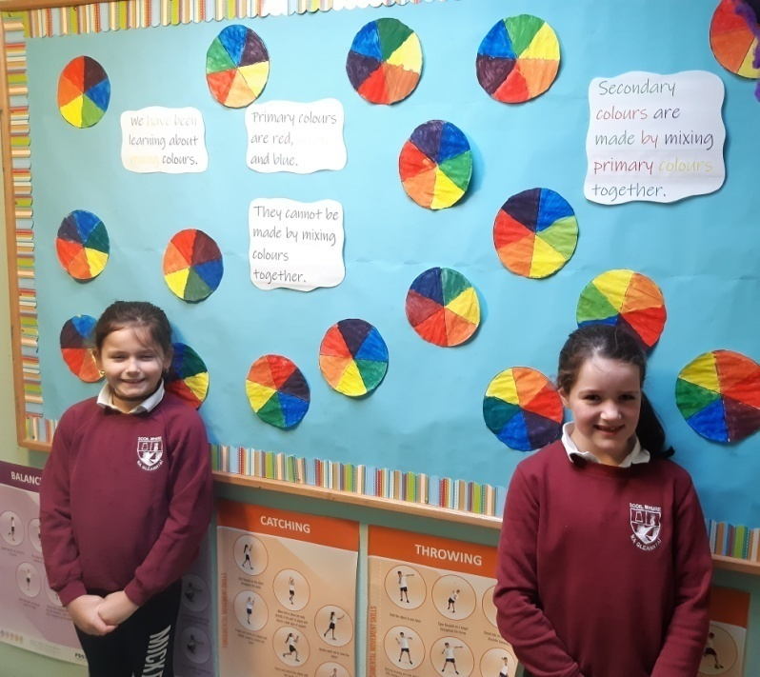

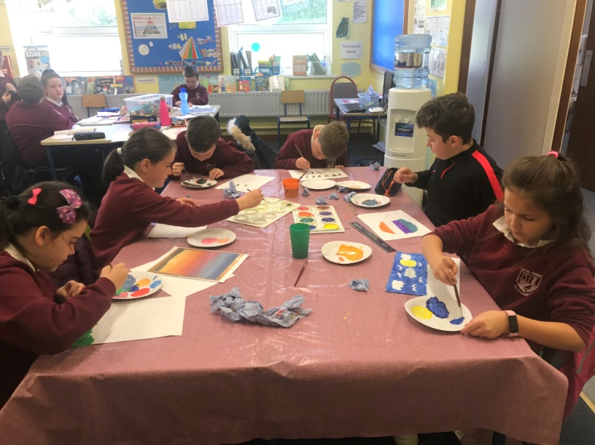

**Funky Face Masks!**

The 5th and 6th Class got creative in response to the Coronavirus pandemic. They designed their own face masks with some hidden surprises when the flap is released and the mask is removed!

**Selfies!**

Ms Kerrigan’s Junior and Senior Infants made fantastic self-portraits. They included details such as their eye colour, hair colour and noses. Of course, everyone had a big smile!

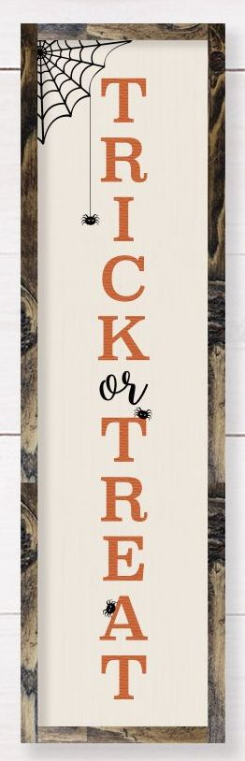

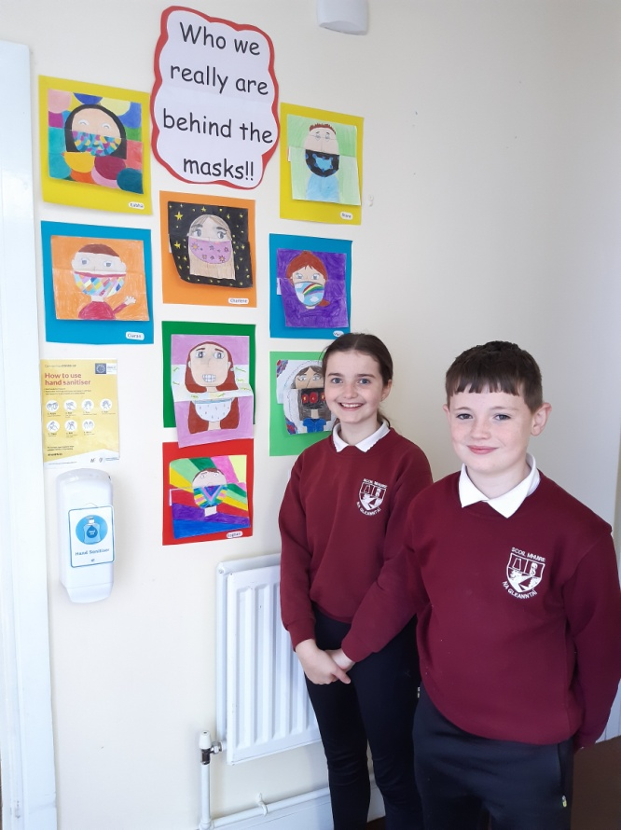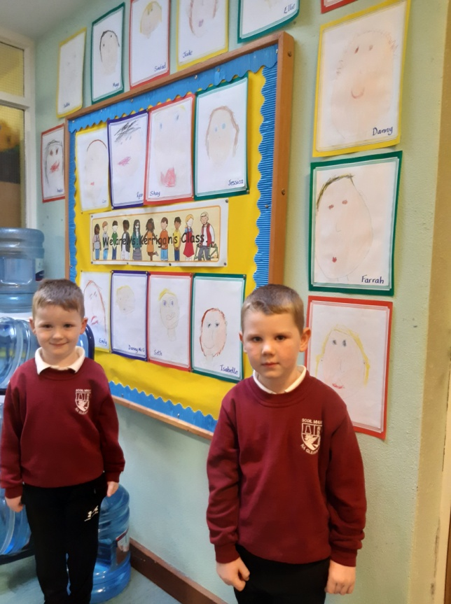

**School Closures 2020/2021**

**Christmas Break**

Closed from Wednesday 23rd December / Re-opening on Wednesday 6th January 2021

**Spring Mid-Term Break (February)**

Closed on Thursday 18th & Friday 19th February 2021

**St. Patrick’s Day**

Closed on 17th March 2021

**Easter Break**

Closed from 29th March / Re-opening on Monday 12th April 2021.

**Other Closures**

Closed on Monday 3rd & Tuesday 4th May (Bank Holiday)

Closed on Monday 7th & Tuesday 8th June (Bank Holiday)

**Summer Holidays**

School will close on Friday 25th June 2021

**Budding Artists**

Check out Darragh Gildea’s beautiful self-portrait of Vincent van Gogh. Van Gogh was a Dutch painter who was born in 1853 and his paintings are very popular even today. We think Darragh’s work is just as good as the original!

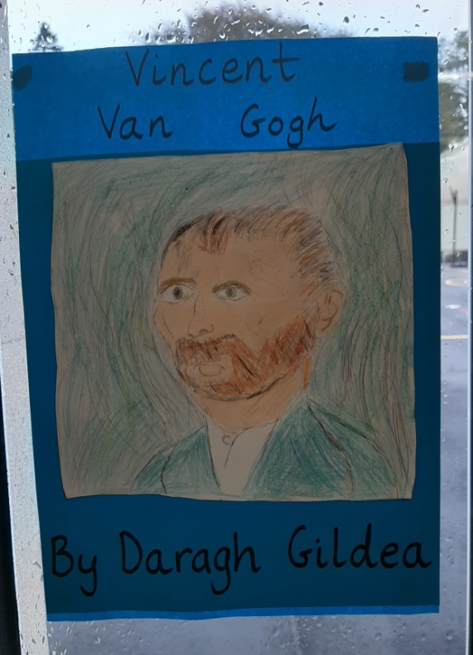

**Board of Management:**

* The Board of Management manages the school on behalf of the patron and is accountable to the patron and the Minister. The Board must uphold the characteristic spirit (ethos) of the school and is accountable to the patron for so doing.
* Board of Management positions are as follows:
* Chairperson: Harry Reid (Patron nominee)
* Acting Chairperson: David Kelch
* Patron Nominee: Fr. Gerard Cunningham
* Principal (Acting): Tracey Whyte (Secretary)
* Staff Representative: Lelia Kerrigan
* Parent Representative: Lorraine McLoone (Risk Assessment)
* Community Representative: Eileen McDyer (Safety Officer)
* Community Representative: Patricia Molloy (Treasurer)
* School policies are available to view on the school website and a hard copy is available from the secretary. Review dates are on the policies and all parents are welcome to contribute to the review.
* Everyone in Scoil Mhuire wishes our Chairperson Harry Reid all the best and look forward to seeing him in the corridors of Scoil Mhuire and hearing of his exploits on the golf course soon!

**Stay Warm!**

As winter approaches, it is really important that the pupils layer up as classroom heat will be reduced in order to keep rooms fresher and well ventilated. From November onwards wear an extra layer or two to keep your child cosy and snug in class and don't forget to bring a coat! Pupils will be going out for fresh air most days unless the weather is extremely wet or windy.

