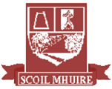

**Scoil Mhuire**

**Newsletter Christmas 2018**



Happy Christmas from Sammy McNollag!

It is hard to believe we have already come to the end of our first school term. As you can see from our newsletter we have been extremely busy in the past four months both in and outside the classroom. Our Junior Infants have settled in great and have been a wonderful addition to our school family.

I thank the staff of Scoil Mhuire for their commitment and dedication to the school and the attention and care that is given to each child. I also thank the Board of Management for the encouragement given to staff and the foresight that is shown to further enhance the lives of all those in Scoil Mhuire. We send regards to Master McCann and Bríd Gavigan and hope they return to full health soon.

During this special season we think of all those from the school community who have lost loves ones during the year. We remember them this Christmas time.

Finally I thank the most important people of the school – the boys and girls. We are so lucky to have such great children in the school and we all hope that they have the joyous and peaceful Christmas they deserve- full of love, laughter and happy memories.

Cróna Rodgers (Acting Principal)

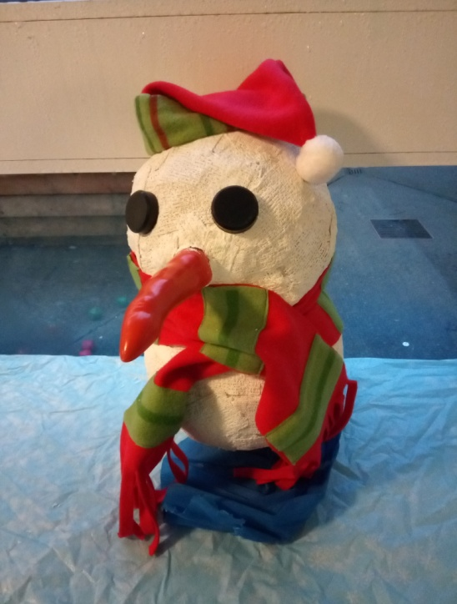

**Glenties**

**Christmas Shoebox Appeal**

We were overwhelmed by the generosity shown in response to our Team Hope Christmas Shoebox Appeal. Our school community donated 70 boxes which were filled with gifts and essential items and these will now be shipped to children in poor parts of the world in time for Christmas. On behalf of the boys and girls who receive them, thank you!

In this newsletter:

* Stories from the Past
* Literary & Art Successes
* Fundraisers
* Cross Country Athletics
* Maths Week...

and much more!

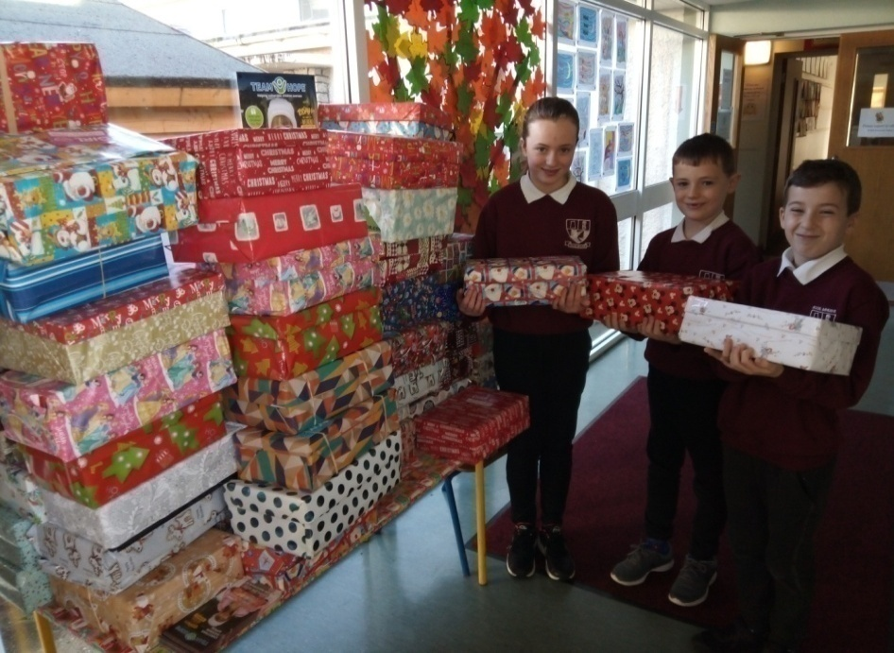

**Welcome!**

We extend a warm welcome to the new Junior Infants who have joined us this year! We hope you make many happy memories in Scoil Mhuire!

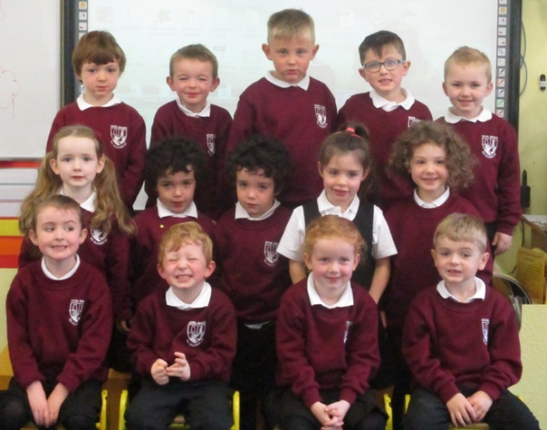

**Stories from the Past**

The school had great success in this year’s Harvest Fair art competition held in September. The theme of this year’s competition was ‘Stories from the Past’ and the winners were Anton Campbell, Cora Doherty, Rachel Boyce, Ailbhe Doherty, Maria McLoone, Caoimhe Boyle, Eoghan Quinn, Thomas Brennan, Sofia McGettigan, Gina Gonda, Alicia Bonner, Darcie McLoone, Rachel Quigley, Lilly Bonner, Isla Donoghue and Kori Browne.

By Eve Boyle Carr and Cathy Browne

**Say Yes to the Dress Fundraiser**

Scoil Mhuire Parents’ Association hosted a ‘Say Yes to the Dress’ Fundraiser in the Highlands Hotel on the 27th of April. We would like to thank the Parents’ Association for organising the event in which €4200 was raised. Thank you to everyone who contributed in any way to a very successful night!

By Shauna Molloy & Ailbhe Doherty

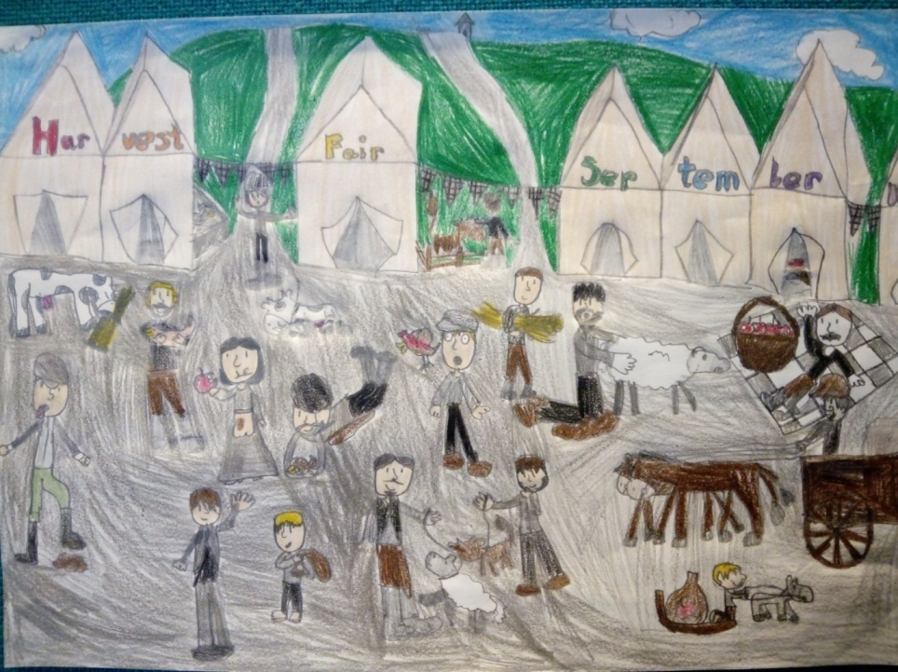





**Hoot Hoot!**

The Junior and Senior Infants produced a beautiful art display of owls they read about in *Owl Babies* by Martin Waddell. They painted depictions of Sarah, Percy and Bill!

**Budding Artists**

Ms Eleanor’s 5th and 6th Class were learning about the famous French artist Georges Seurat. They painted beautiful pieces using an artistic technique known as ‘pointillism’. Seurat used this technique in many of his paintings such as *Sunday Afternoon on the Island of Grande Jatte*.

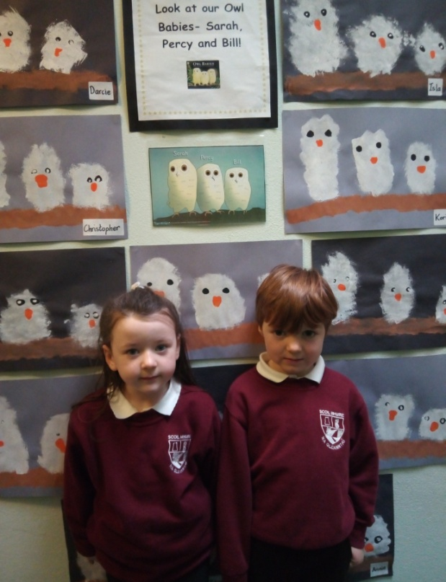

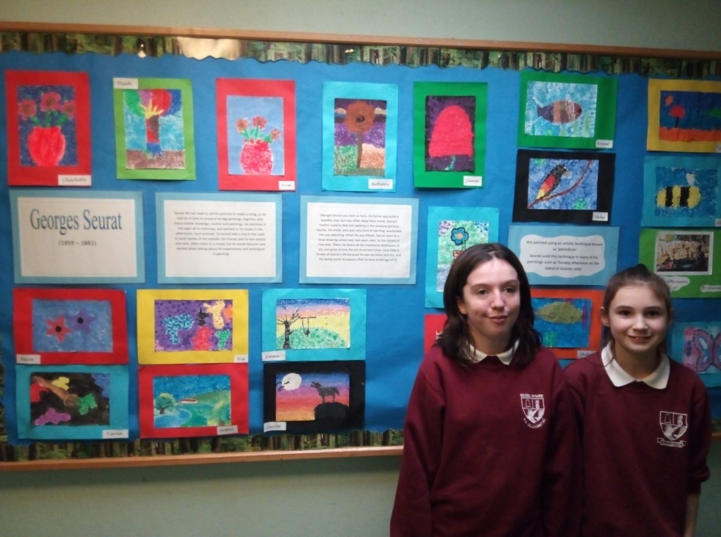

**Pantomine**

On the 10th of December 4th, 5th & 6th Classes attended the pantomime *Peter Pan* in the Millennium Forum. It was a story about a family with two boys, John and Michael, and their older sister, Wendy. One night they got a visit from Peter Pan and with the help of some pixie dust and his friend Tinker Bell he taught them how to fly. He took them to Neverland where they met the lost boys and the American-Indians. They also defeated Captain Hook before returning home. It was hugely entertaining and everyone had a great day!

**Summer Stars**

Congratulations to John McLoone in 2nd Class and Maria McLoone in 4th Class who became Reading Stars over the summer by reading a number of books from their local library! Here’s what Maria has to say about the initiative: *I love doing Summer Stars because it gives me a great chance to read and visit Dungloe library and I get a medal and certificate at the end. Amazing! If you want to sign up all you have to do is visit the local library, check out some books and sign up. It’s that easy! You have to fill in a card and write down the names of eight books you read although you can read a lot more. Simply bring it in before school starts and that’s it. Also, when you return each time you get a different prize such as pencils or notepads.* Well done Maria and John!

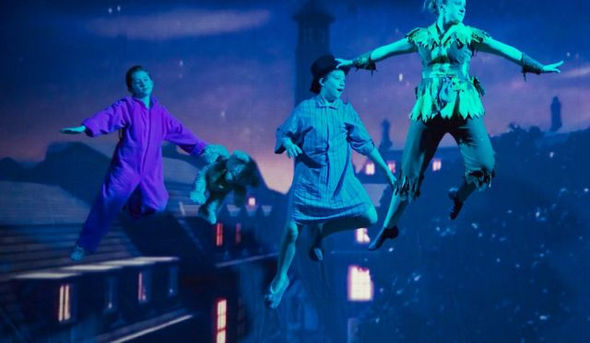

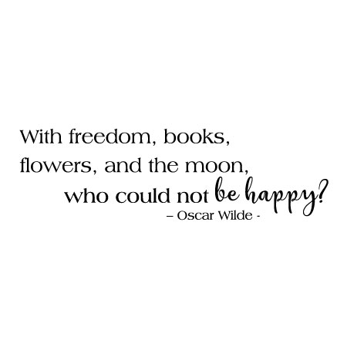

**Fanzini Brothers**

On the 3rd of October, the 2nd – 6th Class pupils of Scoil Mhuire attended a play in Ardara as part of the Bluestacks Arts Festival. It was both written and performed by Fanzini Productions and involved a duo performing various skits and comedies. The play was geared towards a younger, primary school audience and we had a great time watching it.

By Tierna Brannigan

**National Chess Month**

November was National Chess Month and to celebrate all the classes learned some basic chess skills. Since being introduced to chess the older boys and girls in 6th Class have been helping the younger children play the game and learn some valuable social, mental and tactical skills!

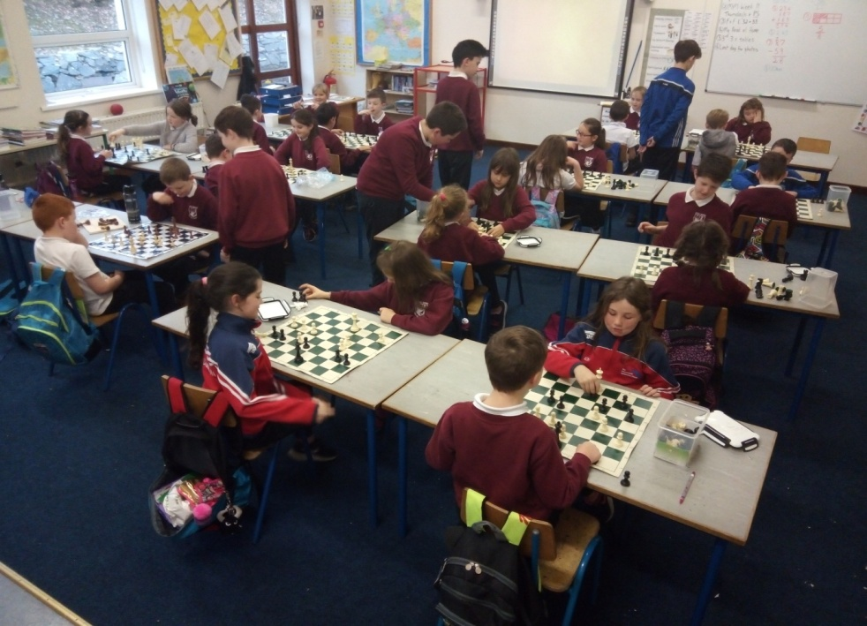





**Funky Art**

Check out the cool houses the 4th and 5th Classes produced in the lead up to Hallowe’en! They drew the creative pieces using pastels on to black backing paper.

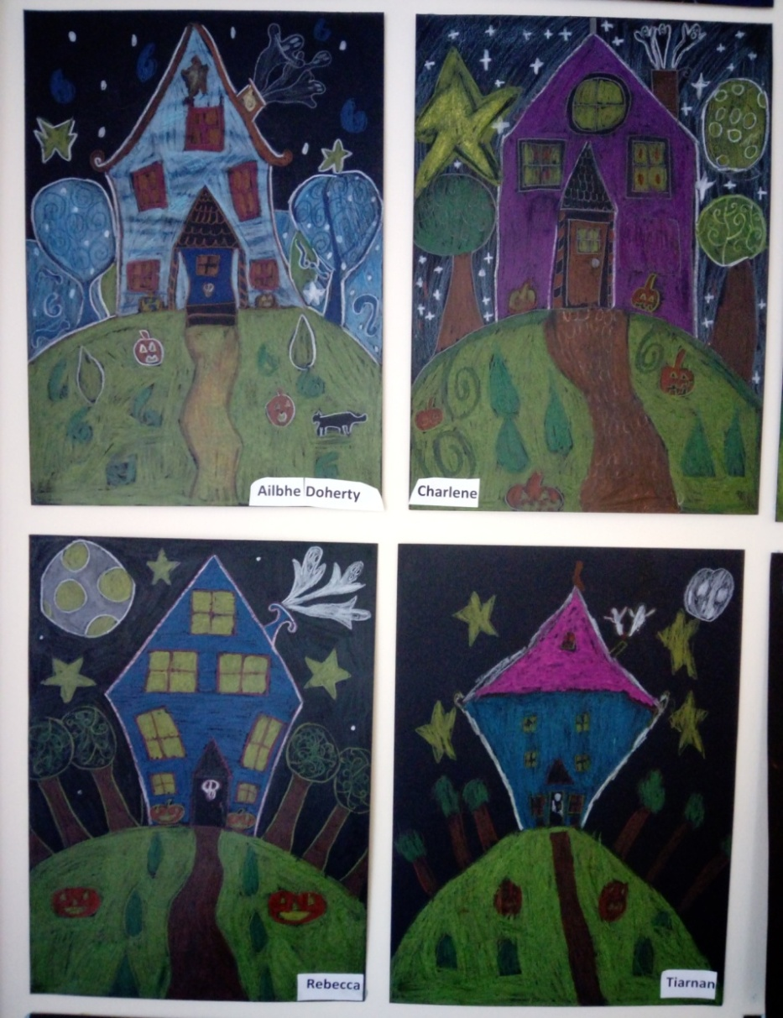

**Glenveagh National Park**

On October 9th the 2nd and 3rd Classes visited Glenveagh National Park and Castle. We went on a walk in the woods and collected lots of colourful leaves, acorns, pinecones and berries. We took shelter in a hut during a rain shower and afterwards we went on a bug hunt and discovered big, hairy spiders, small ants, woodlice and a centipede. We then got a tour of the castle and visited the dining room which had a fake door, the drawing room which had a study table, the sitting room, bedrooms and even the ghost room! We even visited the beautiful gardens and entered a bamboo maze!

By Saoirse McDermott, Caoimhe Boyle and Éabha Molloy

**School Mass**

On the 11th of October Scoil Mhuire’s start of the year mass was held in St. Connell’s Church. Children from the school participated in the mass. Readings were said by Daniel Breslin, Shauna Molloy, Áine Brannigan, Erin Bonner and Eva Breslin Ward. Offerings were taken up by Áine Bonner, Joseph Sanga, Kelsey Boyle and Keilan Doherty while children also took part in singing and altar serving. It was served by Fr Gerard who did an amazing job and was very well attended by the community!

By Emily Browne and Eva Breslin Ward

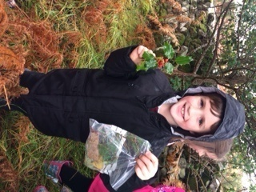

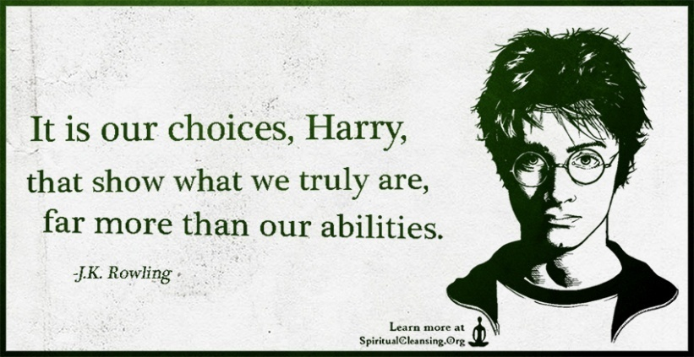

**Allingham Arts**

Congratulations to Maria McLoone, Lara Lynch, Dervla Hegarty and Cora Doherty who were all successful at the annual Allingham Arts Festival this year. Maria McLoone came 2nd in the Junior category with a short story entitled *Under My Bed*. Lara Lynch’s beautiful art picture *Sunrise* finished 2nd in the Senior U-13 category while Dervla Hegarty’s short story *Lilli* was winner in the U-13 category. Cora Doherty’s poem *Autumn* came in 1st place in the Senior Primary School category. Well done, girls!

**Cathy Cassidy**

On September 29th Dubray Books held a book festival called Storyfest. It was held in Dundrum in Dublin. There were lots of authors and illustrators at the Storyfest. I loved meeting Cathy Cassidy. She was very kind and friendly. We made friendship braclets. She told us that if you tie the bracelet too tight and you have to cut it off you may cut through the friendship. She then did book signing in the bookshop and I received her autograph! Judi Curtin was supposed to be there but unfortunately she wasn’t able to attend. I also met the creator of Henry Hugglemoster, Niamh Sharkey and the illustrator Don Conroy.

By Maria McLoone

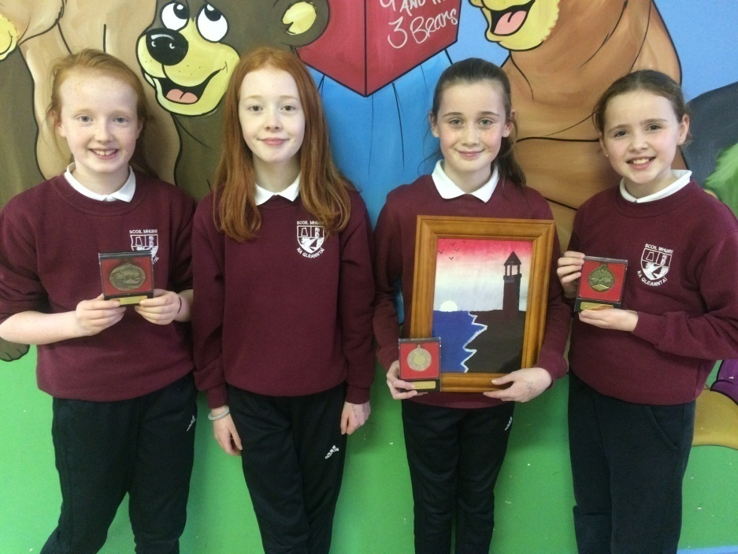

**Drama**

Over the past few weeks Maura Logue has been visiting the school to take all the classes for drama. It has proven to be a huge hit with everyone and is really fun! Activities include drama games and acting out scenes in groups. Maura encourages us to use new and interesting words rather than ‘nice’ and ‘good’. It has been a really enjoyable and worthwhile experience for us all. We thank Maura for coming into the school over the last few weeks!

By Danny Brown

**Autumn**

*Black, inky berries gathered greedily from the thorny briars.*

*Red, bushy squirrels collecting carefully lots of crunchy nuts.*

*Orange, crunchy leaves falling slowly from the giant trees.*

*Loud migrating birds flying quickly through the big blue sky.*

*Small, brown helicopters falling swiftly from the cold air.*

*Spooky, stubby hedgehogs curling up cosily in their warm den.*

*Ripe, crunchy apples falling loudly from the tall trees.*

*Red, bushy foxes sleep lazily in their cozy den.*

By Cora Doherty

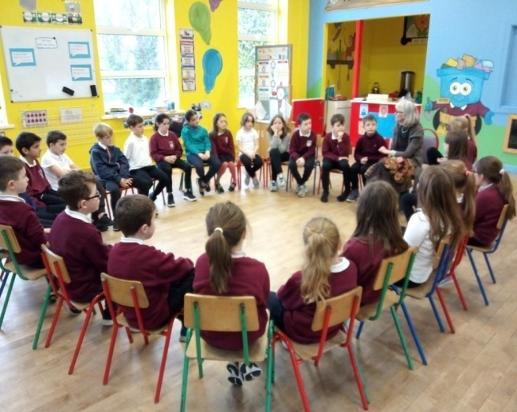

**Cash for Clobber**

Thanks to everyone who sent in items for our Cash for Clobber collection before Hallowe’en. We’ll be collecting for another one in January!

**Christmas Cards**

Thank you for supporting our recent fundraiser by purchasing the children’s specially designed Christmas cards. We had tremendous fun designing and drawing our cards and raised €317 for the school in the process!

**Autumn Trees**

The Senior Infants and 1st Classes painted autumn trees using their finger tips to make the leaves. Look at the beautiful orange, yellow, crimson and brown colours they used that we associate with Autumn!

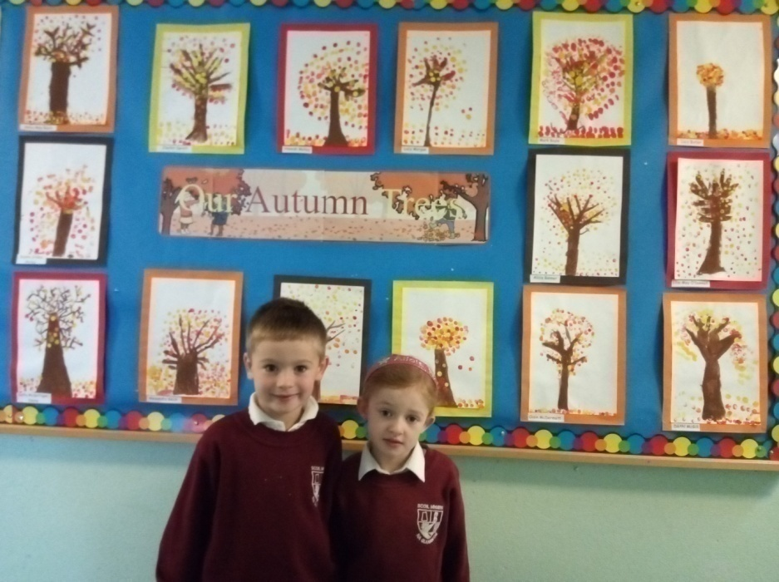

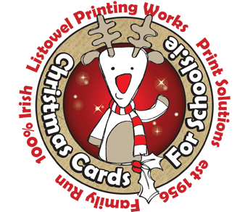

**Maths Week 2018**

Scoil Mhuire participated in Maths Week which was held from 13th - 21st October.On Monday we played chess with Mr. Regan with classes from 1st all the way up to 6th. Older children helped younger classes to learn how to move the pawns and then we eventually added the king to the board.On Tuesday we had a maths quiz. We tested our maths to see which team was the best at maths!Throughout the week we had maths challenges. There were tricky questions for the junior classes and a different question for the senior classes each day. They really got us using our problem-solving skills!On Friday we had an assembly to see who won all of the challenges and to give out prizes for the art competition which had us using our ‘maths eyes’ to look at the world around us. Here’s a problem you could try to solve: Sarah is three times Peter's age. Twice their combined age is 32. How old is Peter?

By Phelim Boyle and Shane Boyle



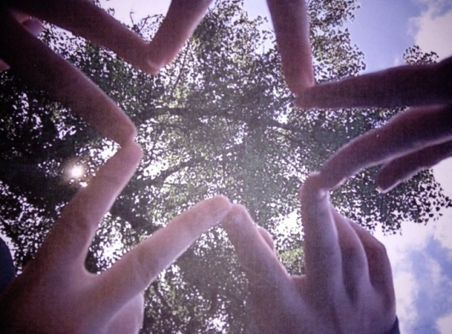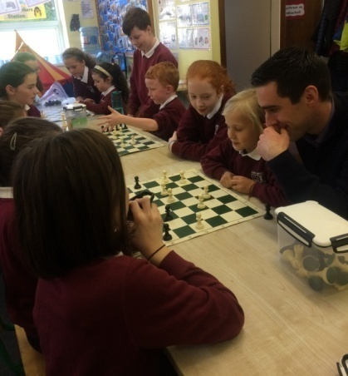

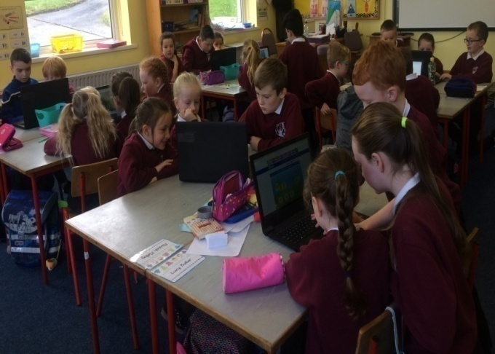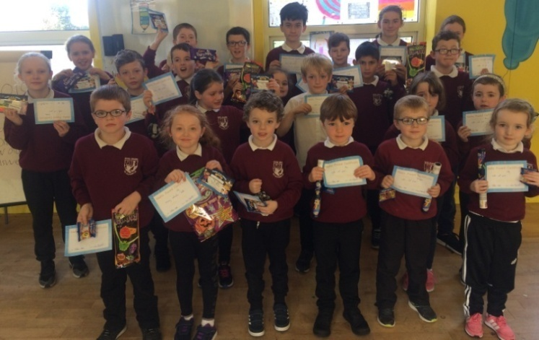

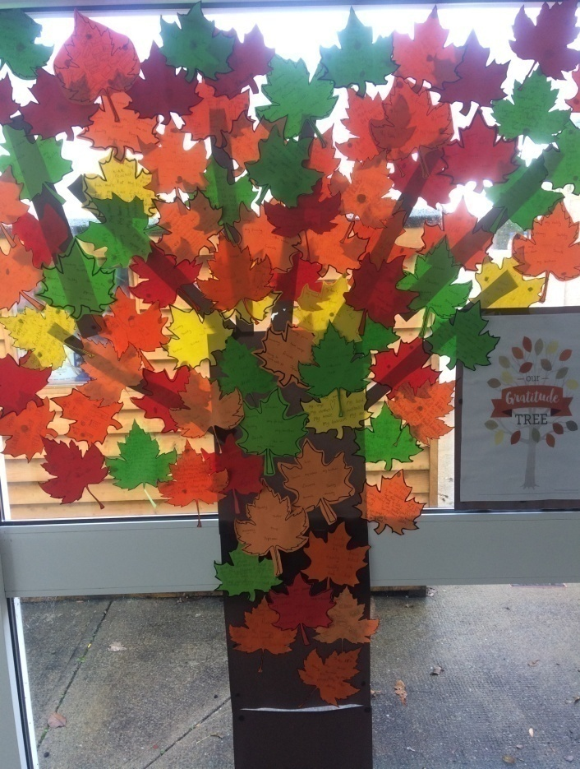

**Mental Health Week**

For the week of the 1st to the 7th of October our school participated in Mental Health Awareness Week. During this week we meditated, kept a happiness journal and enjoyed mindful colouring. Every child in the school got a cut-out of a leaf and wrote one thing they were grateful for and then we posted it on ‘Our Gratitude Tree’. Some classes started reading a book called ‘Headbomz’ that the school got from the ISPCC as part of their ‘Talking Makes Us Stronger’ campaign. We learned a lot about how important mental health is. We learned these facts: your mental health is your feelings and emotions and has nothing to do with physicality. Most of the time your mental health is as important as your physical health. Mental health is very important and you can affect someone just by what you say. If you smile and try to stay positive it will help other people to be happy also!

By Conan Brannigan and Elijah Sangha



**Sleighs**

*Sleighs! Sleighs! Sleighs!*

*Pretty, powerful, packed sleighs*

*Fun, fast, full sleighs*

*Marvellous, mystical, magical sleighs*

*Sleighs! Sleighs! Sleighs!*

By Niamh Heekin Sweeney (2nd Class)

**Cumann na mBunscol Quiz**

Well done to Orin Brannigan, Shauna Molloy, Orla Molloy and Cian Gildea who represented the school at the annual GAA quiz recently. They answered questions relating to topics such as sport, music, history and geography and did us so proud! Well done, guys!

**Lunches Award**

Congratulations to Freshtoday, our lunches supplier in Scoil Mhuire, who have recently received a prestigious national accreditation and in doing so have now become the leading school lunch supplier for Hygiene and Food Safety in Ireland! They received the distinction from EIQA, the National Standards Authority of Ireland for their sourcing, purchasing, preparation, production and delivery of school lunches. From a small, startup business in 2010, Freshtoday is now a leading supplier of school lunches nationally and to receive this award in such a short space of time is a testament to their ongoing commitment in striving to provide the very best healthy lunches. Congratulations to Freshtoday from all in Scoil Mhuire!

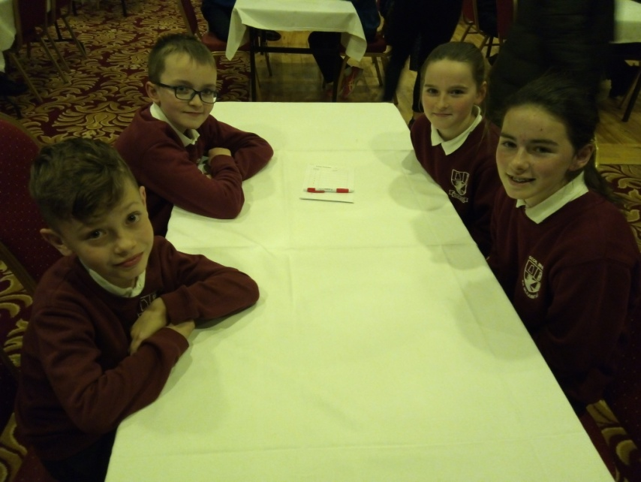

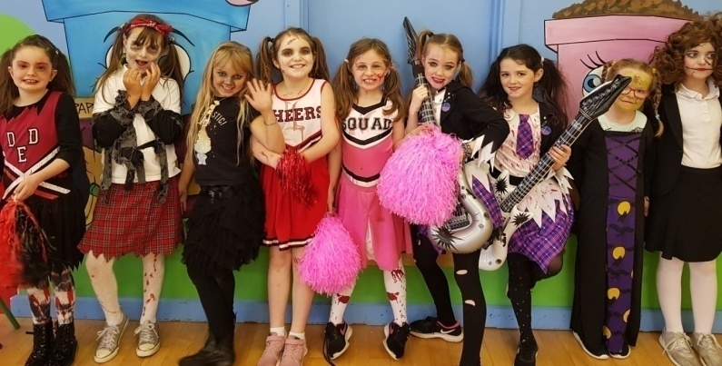

**Hallowe’en Dress Up Day**

We had tremendous fun dressing up at Hallowe’en for Temple Street Children’s Hospital. We played a game in which we had to put our hands into a cup of slime and see what we could find. There was jelly in some of the cups along with a toy. We entered a spooky room in the school where there was a box that you had to put your hand through to find a surprise. Many children were frightened when a fake skeleton crept up behind them! Overall, we had a tremendous day and raised some funds for a good cause!

By Charlene Campbell & Rebecca Quigley

**Santa Fun Run**

We would like to say a huge ‘Thank You’ to everybody who supported the Parents’ Association Santa Fun Run 2018 which took place on the 25th of November. It was a beautiful, crisp day and everyone had an enjoyable afternoon. The first boy and girl home from the 5km U-9 race was Donnacha Malone and Éabha Molloy. The first boy and girl home in the U-13 race was Cora Doherty and Conor Farell. The first boy and girl home from the U-16 category was Seán Doherty and Cliona Campbell. The overall winner was Seanie Mc Devitt and the first lady home was Edwina Doherty. The first man home from the 3km walk was Raymond Brennan and the first lady home was Muriel Hegarty. After the race there was tea and refreshments and lots of spot prizes were won. All of the children who participated received goodie bags. It was a fun day for all and thanks so much to the Parents’ Association for organising it!

By Donnacha Malone & Sophie Brennan

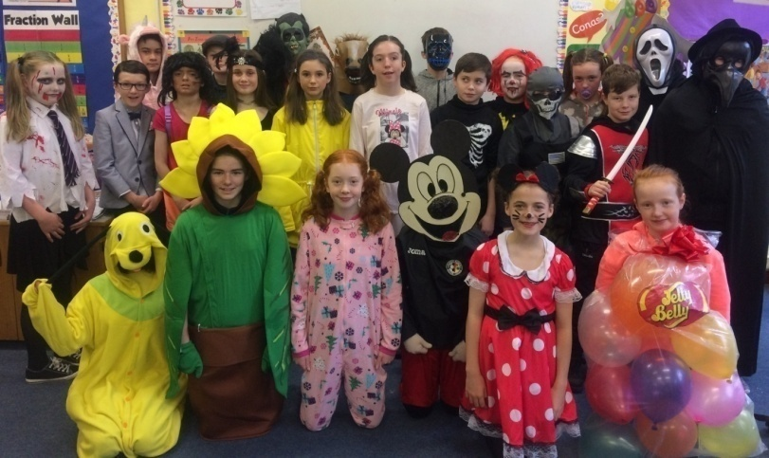







**Christmas**

***I see*** *decorations glinting through windows as lights glow on decorated trees*

***I smell*** *the delicious turkey cooking in the kitchen*

***I hear*** *the joyous ‘Oohs’ and ‘Ahhs’ of people opening gifts*

***I feel*** *the warmth of the fire crackling in the stove*

***I taste*** *the delicious dinner... Mmmm!*

***I think*** *of the poor children who are unfortunate and have no bed to lie in tonight.*

By Anton Campbell

**Environmental Studies**

Senior Infants & First Class had lots of fun exploring their local environment on an autumn nature walk. They even did a leaf hunt to see how many different types of leaves they could identify!

**School Closures 2018/2019:**

**Christmas Break**

Closing on Friday 21st December / Re-opening on Monday 07th January.

**Spring Mid-Term Break (February)**

Closing on 15th February / re-opening Monday 25th February

**Easter Break**

Closing on Friday 12th April / Re-opening Monday 29th April.

**Other Closures**

Closed on Monday 18th March (Bank Holiday)

Closed on Monday 6th May (Bank Holiday)

Closed on Monday 03rd June (Bank Holiday)

**Summer Holidays**

School will close on Thursday 27th June 2019

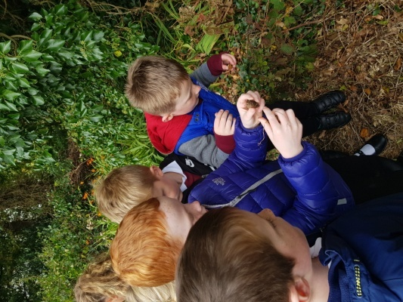

**Board of Management:**

* The Board of Management manages the school on behalf of the patron and is accountable to the patron and the Minister. The Board must uphold the characteristic spirit (ethos) of the school and is accountable to the patron for so doing.
* Board of Management positions are as follows:
* Chairperson: Harry Reid (Patron nominee)
* Patron Nominee: Fr. Gerard Cunningham
* Community Representative: Eileen McDyer (Safety Officer)
* Community Representative: Francis Brennan
* Principal (Acting): Cróna Rodgers (Secretary)
* Staff Representative: Eleanor McGill
* Parent Representative: Patricia Molloy (Treasurer)
* Parent Representative: Joe Gavigan (Capital Projects)
* School policies are available to view on the school website and a hard copy is available from the secretary. Review dates are on the policies and all parents are welcome to contribute to the review.

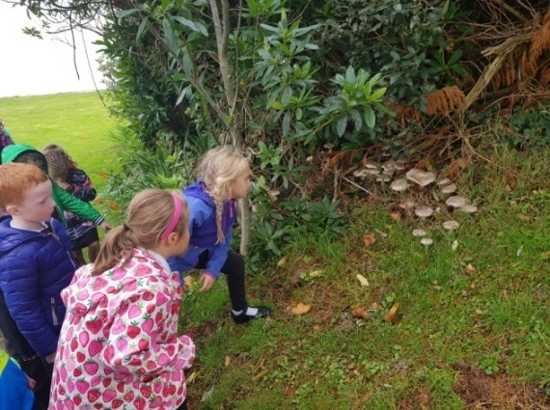

**Aistear Fun**

Senior Infants & First Class have been having fun in Aistear getting ready for Christmas in Santa’s workshop. They have been posting their letters to Santa in our Post Office in class!

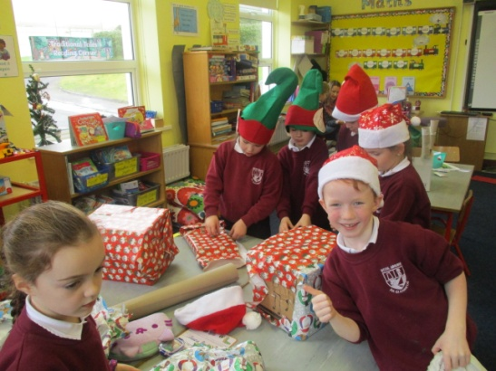

**Hallowe’en Art**

Senior Infants & First class have been busy making some beautiful artwork this year. They made Hallowe’en art by painting a night sky and drawing and cutting out cats and bats to create a silhouette.

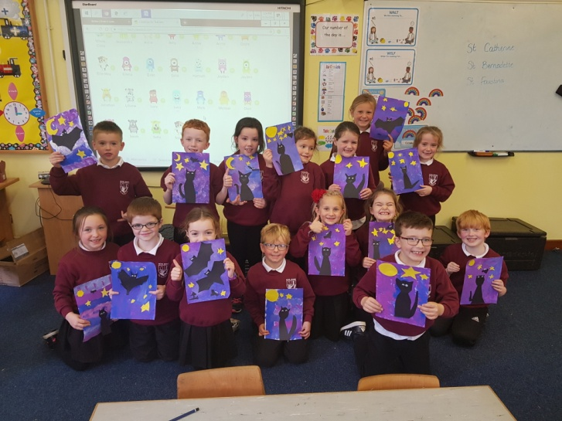

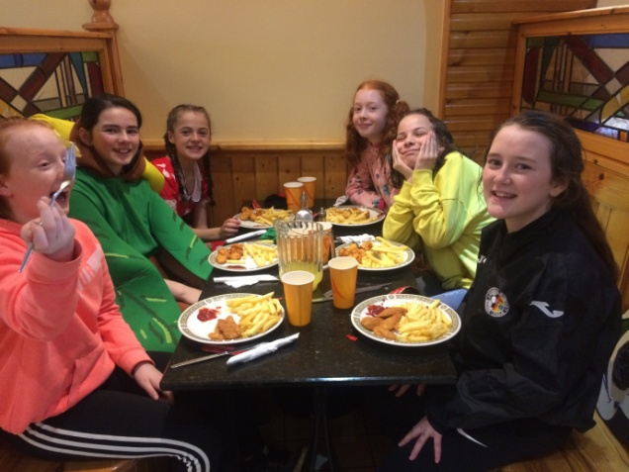

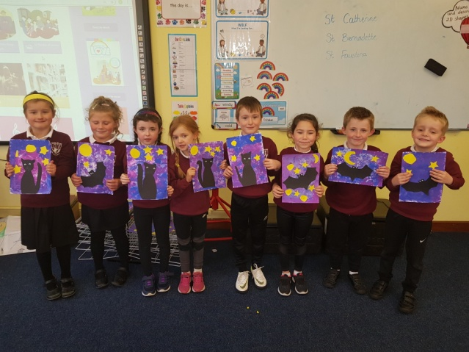

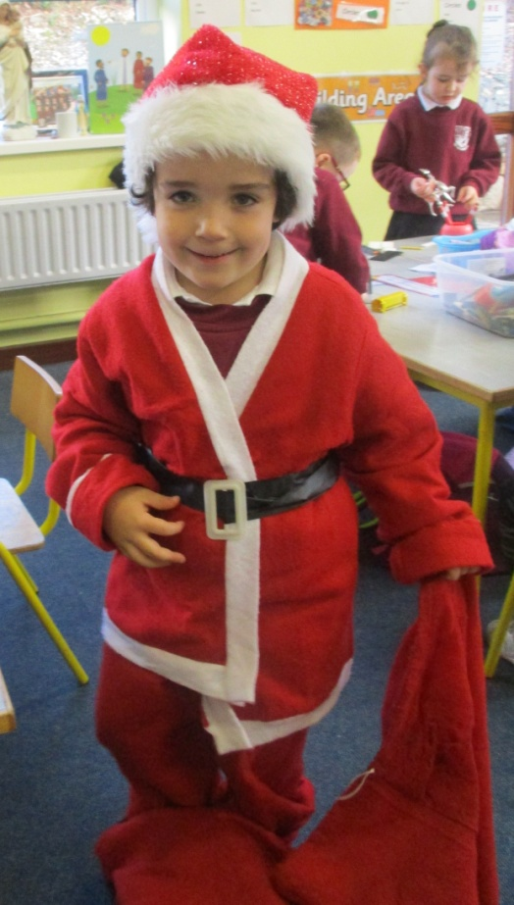

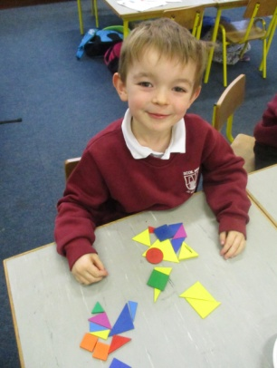

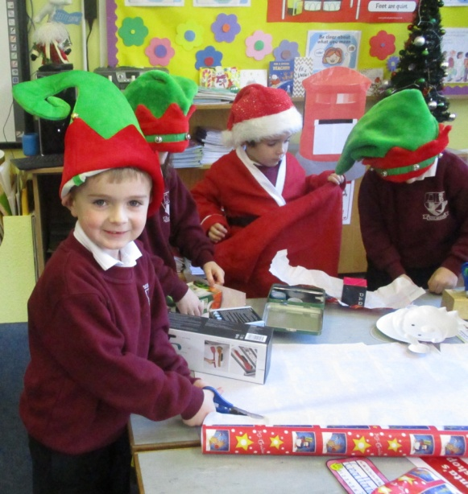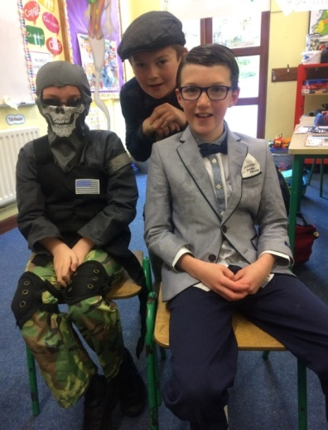

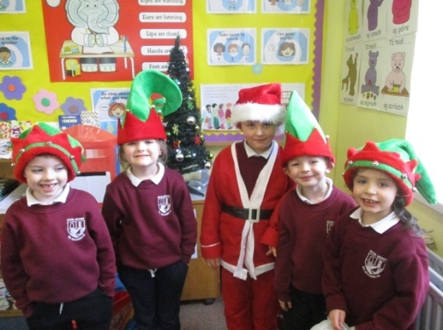

**Basketball**

Many thanks to David Tierney who has been visiting the school in the first term to take all the classes for basketball lessons. We played really fun games like hot seat and the line game and we learned lots of basketball skills such as dribbling, shooting techniques, defensive stances and how to react to rebounds. We then had a tournament day in October along with boys and girls from Kilkenny National School and coaches called Dee, Spencer, Tweedy and Niall from the Young Americans basketball team came in to help with the coaching. They really helped all of us with the basketball and thanks to David for organising it!

By Stephen Mc Devitt & Finn Coughlan

**Cross Country Athletics**

On the 14th of September girls from 3rd class and upwards competed in a cross country race held at the rugby pitch in Donegal Town. It was quite wet and mucky there but it didn’t stop the u11 girls team of Áine Brannigan, Ailbhe Doherty, Aoife McDermott, Cara Mahony, Aoibhinn Brannigan and Shauna Molloy win the overall schools event! The school did very well in all categories with Emily Melly, Éabha Molloy and Sara Byrne competing in the u9 race. Áine Brannigan finished 1st, Ailbhe Doherty finished 2nd and Aoife Mc Dermot finished 3rd all in the u11 race. Cora Doherty and Lara Lynch ran in the u13 race. At the county cross country up in Buncrana the u11 girls team placed 2nd out of the whole county! Well done girls!

By Cora Doherty and Lara Lynch

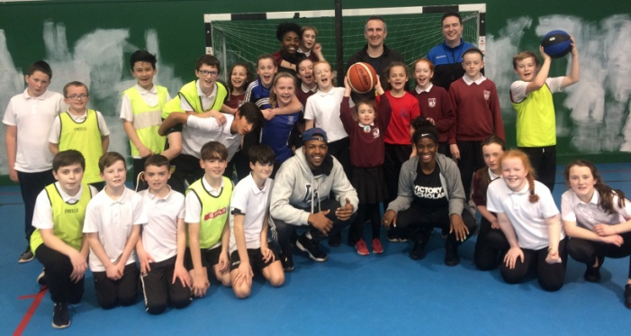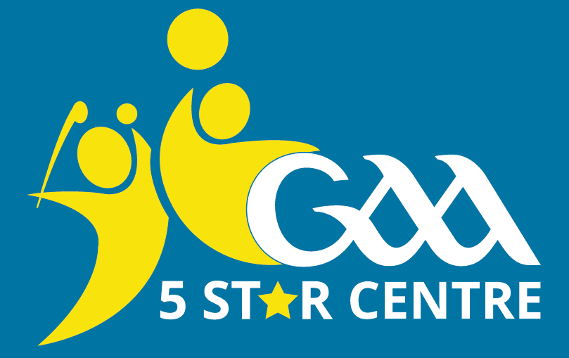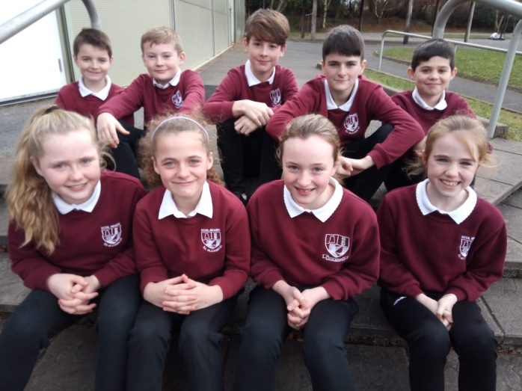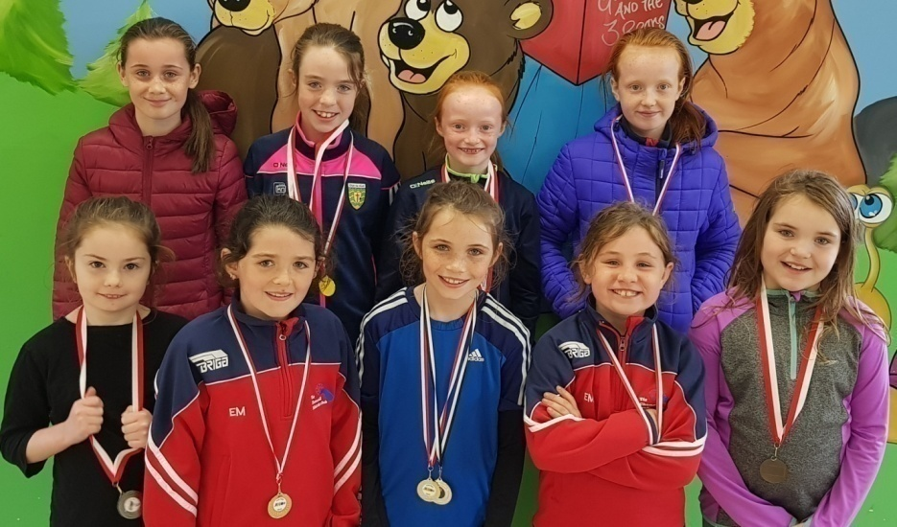

**GAA 5 Star School**

We in Scoil Mhuire have applied to become a GAA 5 Star Centre this year. In order to achieve a 5 Star status each class must engage with Gaelic games activities for one hour every week and we have been busy doing this since September! These activities include everything from body balances to scissor jumps to rounders to skills challenges and Go Games! By undertaking the programme we will have active & healthy bodies, strong self-esteem, confidence and resilience. We will also participate in team and co-operative learning and it will benefit social & community wellbeing. We established a GAA committee in the school and they have been busy looking after all things GAA-related! They are Eve Boyle Carr, Cathy Browne, Conan Brannigan, Danny Brown, Erin Bonner, Jamie Byrne, Daithí Molloy, Ciarán Boyle and Saoirse McDermott. Our ‘Drive for Five’ motto is *Fun, Friendship, Fairness, Freedom, Fitness!*