Junior Infants Booklist 2021-2022
- Planet Maths Junior Infants
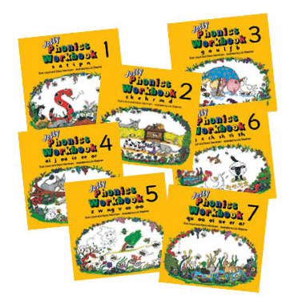
These are the Jolly Phonics Books we use.
- Grow in Love Junior Infants
- Bua na Cainte B Senior Infants (Not a mistake!)
- Jolly Phonics Book 1
- Jolly Phonics Book 2
- Jolly Phonics Book 3

- There’s no need to buy stationary, copies etc- we will get all those things. It is unlikely the children will be allowed to bring in their own pencil cases, colours, rubbers etc in order to avoid cross contamination in the classroom.

- Book Rental and Stationary bills will be issued in September.
- Pupil Insurance (€5) will also be due in September.

